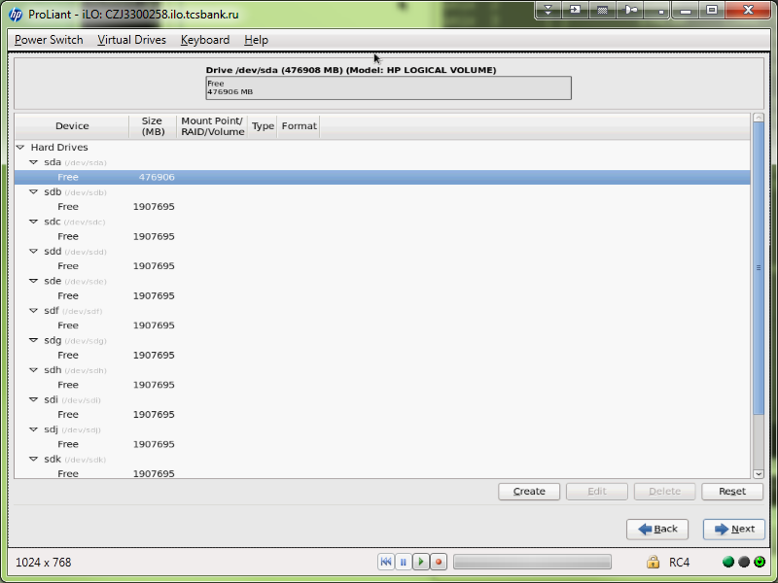

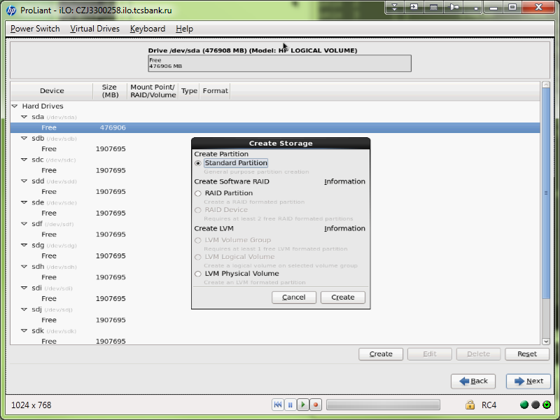

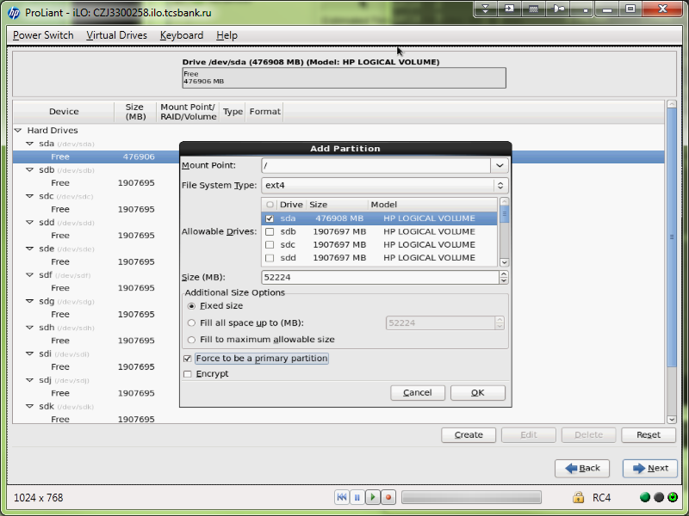

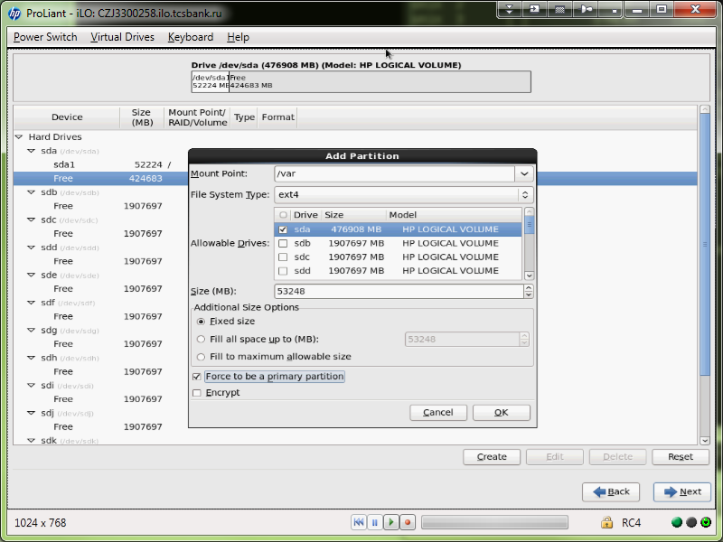

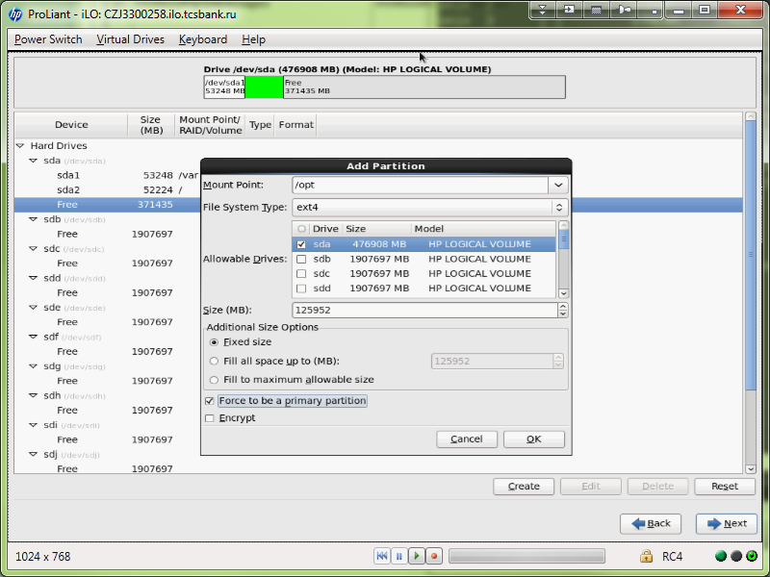

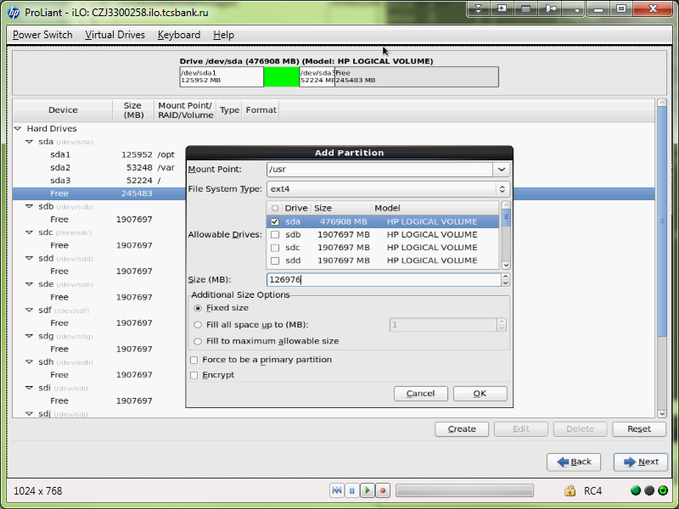

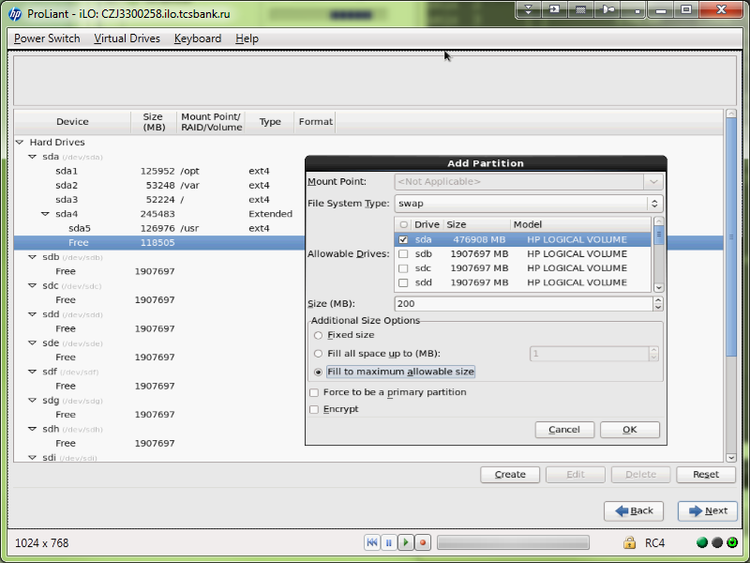

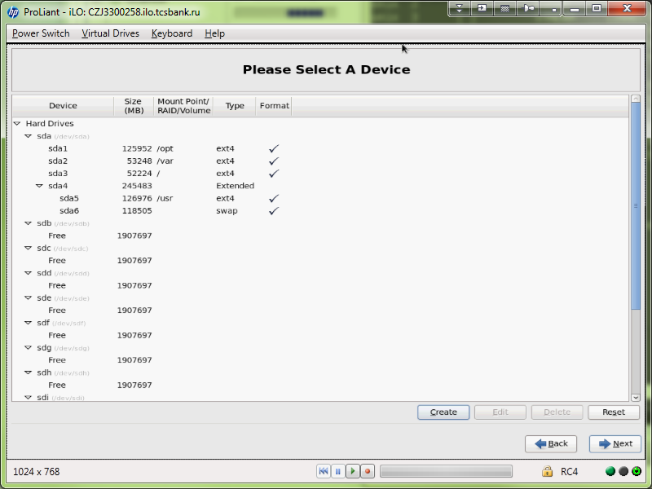

Installing xx-hadoop-cs01x server.

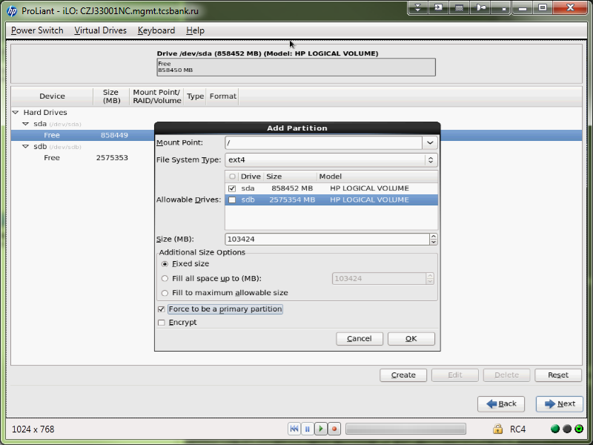

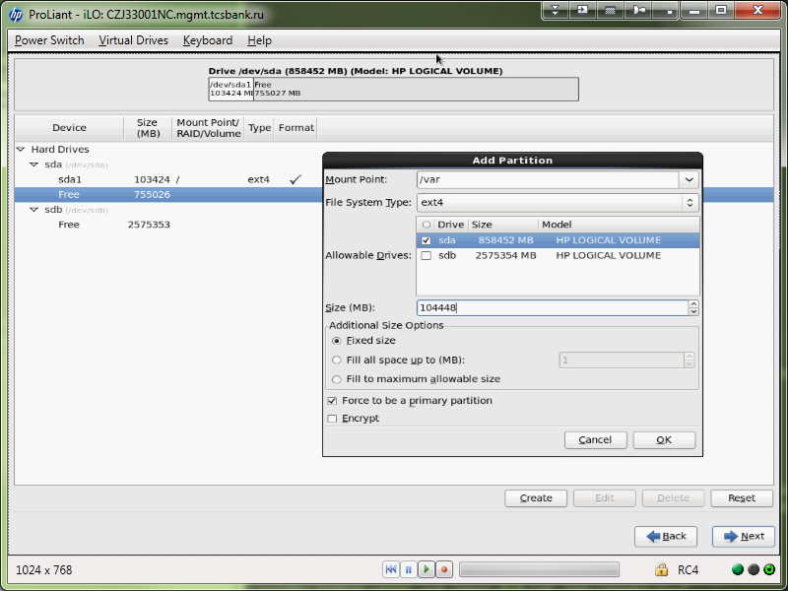

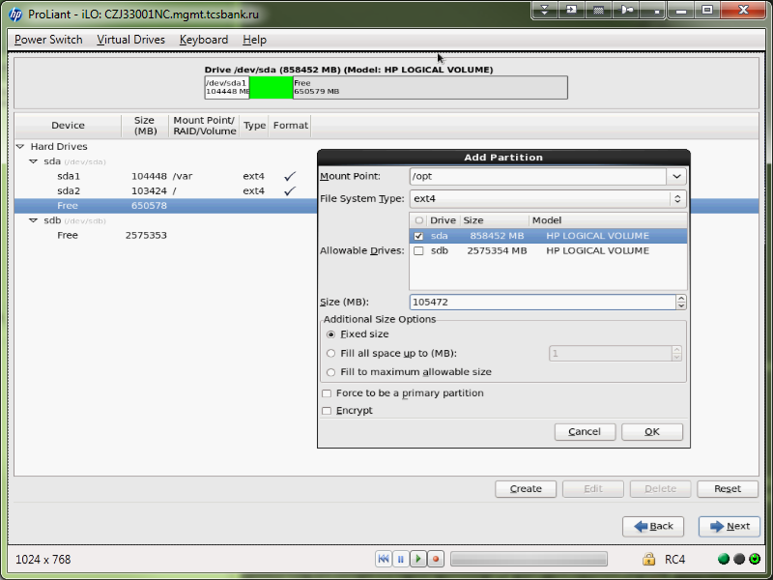

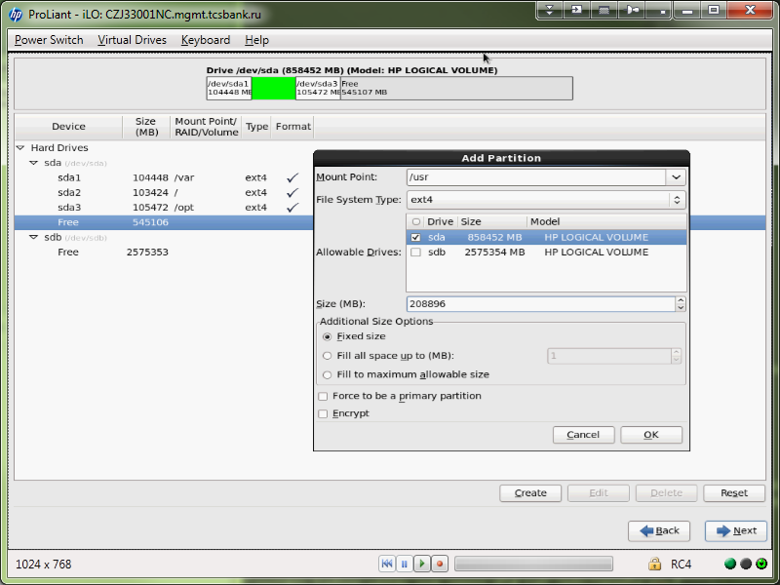

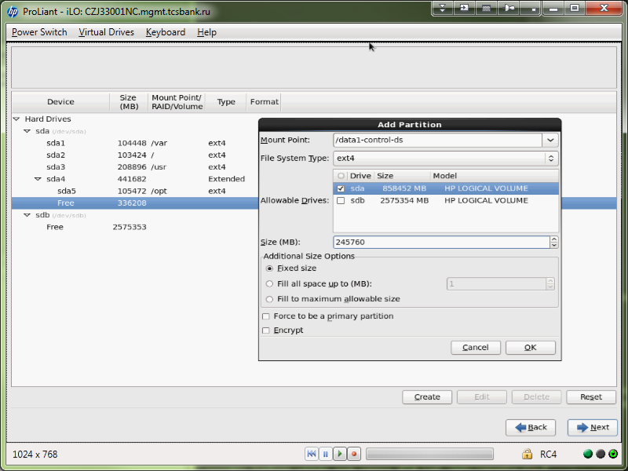

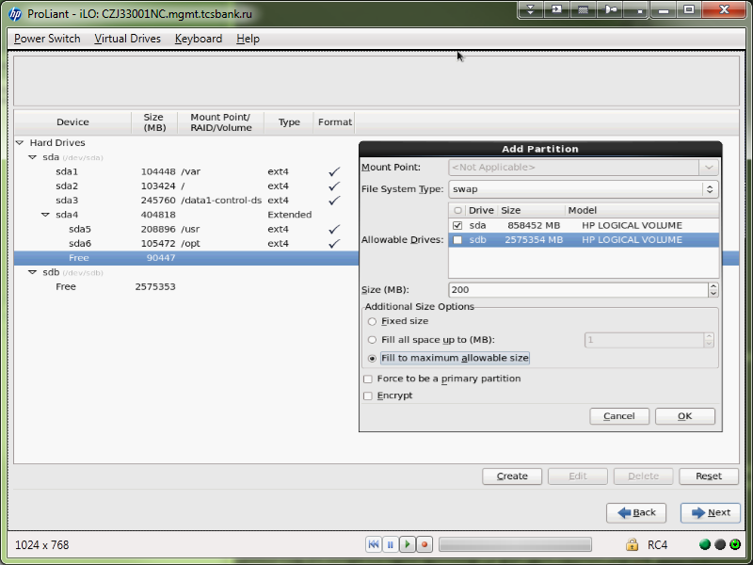

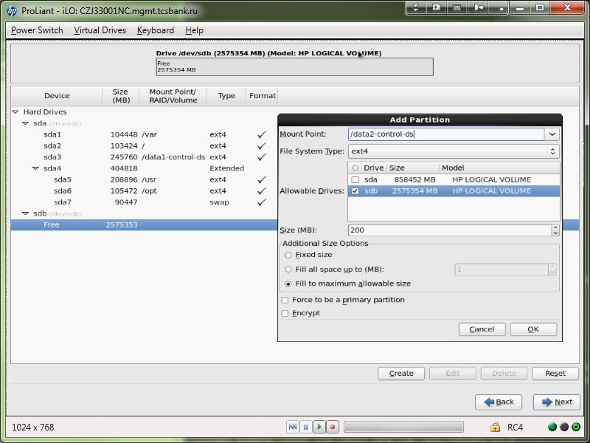

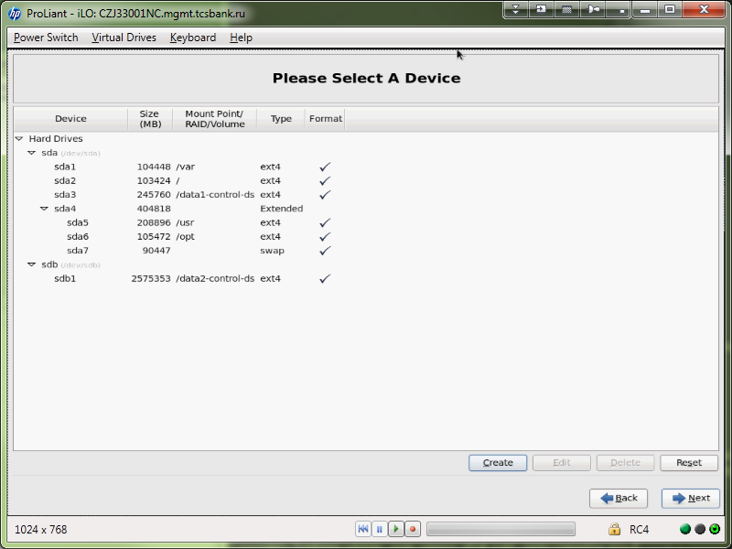

[support@centos00 ~]$ ssh root@10.218.64.14
The authenticity of host '10.218.64.14 (10.218.64.14)' can't be established.
RSA key fingerprint is 00:c4:5f:b5:c9:ae:6a:bc:01:20:1e:ba:65:54:85:f2.
Are you sure you want to continue connecting (yes/no)? yes
Warning: Permanently added '10.218.64.14' (RSA) to the list of known hosts.
root@10.218.64.14's password:
Last login: Fri Oct 11 14:35:48 2013
[root@ds-hadoop-wk04p ~]# df -h
Filesystem Size Used Avail Use% Mounted on
/dev/sda3 51G 412M 48G 1% /
tmpfs 24G 0 24G 0% /dev/shm
/dev/sda1 122G 188M 115G 1% /opt
/dev/sda5 123G 1.6G 115G 2% /usr
/dev/sda2 52G 222M 49G 1% /var

[root@ds-hadoop-wk04p yum.repos.d]# date 101218102013.00
Sat Oct 12 18:10:00 MSK 2013
[root@ds-hadoop-wk04p yum.repos.d]# hwclock --systohc
[root@ds-hadoop-wk04p yum.repos.d]# hwclock --show
Sat 12 Oct 2013 06:10:15 PM MSK -0.437972 seconds
[root@ds-hadoop-wk04p yum.repos.d]#

[root@ds-hadoop-wk04p ~]# yum repolist
Loaded plugins: product-id, security, subscription-manager
This system is not registered to Red Hat Subscription Management. You can use subscription-manager to register.
repolist: 0
[root@ds-hadoop-wk04p ~]# ls /etc/yum.repos.d/
rhel-source.repo
[root@ds-hadoop-wk04p ~]# subscription-manager

[root@smdw ~]# ls -Alh /etc/yum.repos.d/
����� 24K
-rw-r--r--. 1 root root 78 ��� 4 13:11 redhat.repo
-rw-r--r--. 1 root root 529 ��� 16 2011 rhel-source.repo
-rw-r--r--. 1 root root 183 ��� 16 2011 tcs-epel.repo
-rw-r--r--. 1 root root 185 ��� 16 2011 tcs-hp.repo
-rw-r--r--. 1 root root 479 ��� 16 2011 tcs-puppet.repo
-rw-r--r--. 1 root root 440 ��� 16 2011 tcs-rhel62.repo
[root@smdw ~]#

[root@smdw ~]# cat /etc/yum.repos.d/*
#
# Certificate-Based Repositories
# Managed by (rhsm) subscription-manager
#
[rhel-source]
name=Red Hat Enterprise Linux $releasever - $basearch - Source
baseurl=ftp://ftp.redhat.com/pub/redhat/linux/enterprise/$releasever/en/os/SRPMS/
enabled=0
gpgcheck=1
gpgkey=file:///etc/pki/rpm-gpg/RPM-GPG-KEY-redhat-release

[rhel-source-beta]
name=Red Hat Enterprise Linux $releasever Beta - $basearch - Source
baseurl=ftp://ftp.redhat.com/pub/redhat/linux/beta/$releasever/en/os/SRPMS/
enabled=0
gpgcheck=1
gpgkey=file:///etc/pki/rpm-gpg/RPM-GPG-KEY-redhat-beta,file:///etc/pki/rpm-gpg/RPM-GPG-KEY-redhat-release

tcs-epel.repo
[EPEL6]
name=TCS EPEL 6 repository
baseurl=http://monitoring2.tcsbank.ru/repo/epel/6/$basearch/
enabled=1
gpgcheck=0
gpgkey=http://monitoring2.tcsbank.ru/repo/epel/RPM-GPG-KEY-EPEL-6
[rhel-hp]
name=Red Hat Enterprise Linux HP repository $releasever - $basearch - Source
baseurl=http://monitoring2.tcsbank.ru/repo/hp/$releasever/$basearch/current/
enabled=1
gpgcheck=0

tcs-puppet.repo
[puppetlabs]
name=Puppet Labs Packages
baseurl=http://monitoring2.tcsbank.ru/repo/puppetlabs/el/$releasever/products/$basearch
enabled=1
gpgcheck=1
gpgkey=http://monitoring2.tcsbank.ru/repo/puppetlabs/RPM-GPG-KEY-puppetlabs

[puppetlabs-dependencies]
name=Puppet Labs Packages Dependencies
baseurl=http://monitoring2.tcsbank.ru/repo/puppetlabs/el/$releasever/dependencies/$basearch
enabled=1
gpgcheck=1
gpgkey=http://monitoring2.tcsbank.ru/repo/puppetlabs/RPM-GPG-KEY-puppetlabs

tcs-rhel62.repo
[rhel62]
name=Red Hat Enterprise Linux $releasever - $basearch - Source
baseurl=http://monitoring2.tcsbank.ru/repo/tcs/rhel/62Server/cdrom/
enabled=1
gpgcheck=0
gpgkey=http://monitoring2.tcsbank.ru/repo/tcs/rhel/62Server/cdrom/RPM-GPG-KEY-redhat-release

[rhel62-update]
name=Red Hat Enterprise Linux $releasever - $basearch - Update
baseurl=http://monitoring2.tcsbank.ru/repo/tcs/rhel/62Server/updates/$basearch/RPMS/
enabled=1
gpgcheck=0
[root@smdw ~]#

[root@ds-hadoop-wk04p yum.repos.d]# yum repolist
Loaded plugins: product-id, security, subscription-manager
This system is not registered to Red Hat Subscription Management. You can use subscription-manager to register.
puppetlabs | 1.9 kB 00:00
puppetlabs/primary_db | 98 kB 00:00
puppetlabs-dependencies | 1.9 kB 00:00
puppetlabs-dependencies/primary_db | 20 kB 00:00
rhel62 | 4.0 kB 00:00
rhel62/primary_db | 3.1 MB 00:00
rhel62-update | 951 B 00:00
rhel62-update/primary | 228 kB 00:00
rhel62-update 131/131
repo id repo name status
EPEL6 TCS EPEL 6 repository 9,789
puppetlabs Puppet Labs Packages 300
puppetlabs-dependencies Puppet Labs Packages Dependencies 49
rhel62 Red Hat Enterprise Linux 6Server - x86_64 - Source 3,529
rhel62-update Red Hat Enterprise Linux 6Server - x86_64 - Update 131
repolist: 13,798
[root@ds-hadoop-wk04p yum.repos.d]# yum install ruby
Loaded plugins: product-id, security, subscription-manager
This system is not registered to Red Hat Subscription Management. You can use subscription-manager to register.
Setting up Install Process
Resolving Dependencies
--> Running transaction check
---> Package ruby.x86_64 0:1.8.7.352-7.el6_2 will be installed
--> Processing Dependency: ruby-libs = 1.8.7.352-7.el6_2 for package: ruby-1.8.7.352-7.el6_2.x86_64
--> Processing Dependency: libruby.so.1.8()(64bit) for package: ruby-1.8.7.352-7.el6_2.x86_64
--> Running transaction check
---> Package ruby-libs.x86_64 0:1.8.7.352-7.el6_2 will be installed
--> Processing Dependency: libreadline.so.5()(64bit) for package: ruby-libs-1.8.7.352-7.el6_2.x86_64
--> Running transaction check
---> Package compat-readline5.x86_64 0:5.2-17.1.el6 will be installed
--> Finished Dependency Resolution

Dependencies Resolved

===================================================================================================================================================================================
Package Arch Version Repository Size
===================================================================================================================================================================================
Installing:
ruby x86_64 1.8.7.352-7.el6_2 rhel62-update 532 k
Installing for dependencies:
compat-readline5 x86_64 5.2-17.1.el6 rhel62 129 k
ruby-libs x86_64 1.8.7.352-7.el6_2 rhel62-update 1.6 M

Transaction Summary
===================================================================================================================================================================================
Install 3 Package(s)

Total download size: 2.3 M
Installed size: 7.8 M
Is this ok [y/N]: y
Downloading Packages:
(1/3): compat-readline5-5.2-17.1.el6.x86_64.rpm | 129 kB 00:00
(2/3): ruby-1.8.7.352-7.el6_2.x86_64.rpm | 532 kB 00:00
(3/3): ruby-libs-1.8.7.352-7.el6_2.x86_64.rpm | 1.6 MB 00:00
-----------------------------------------------------------------------------------------------------------------------------------------------------------------------------------
Total 13 MB/s | 2.3 MB 00:00
Running rpm_check_debug
Running Transaction Test
Transaction Test Succeeded
Running Transaction
Installing : compat-readline5-5.2-17.1.el6.x86_64 1/3
Installing : ruby-libs-1.8.7.352-7.el6_2.x86_64 2/3
Installing : ruby-1.8.7.352-7.el6_2.x86_64 3/3
rhel62/productid | 1.7 kB 00:00
Verifying : ruby-1.8.7.352-7.el6_2.x86_64 1/3
Verifying : ruby-libs-1.8.7.352-7.el6_2.x86_64 2/3
Verifying : compat-readline5-5.2-17.1.el6.x86_64 3/3

Installed:
ruby.x86_64 0:1.8.7.352-7.el6_2

Dependency Installed:
compat-readline5.x86_64 0:5.2-17.1.el6 ruby-libs.x86_64 0:1.8.7.352-7.el6_2

Complete!
[root@ds-hadoop-wk04p yum.repos.d]#

[root@ds-hadoop-wk04p yum.repos.d]# yum --showduplicates list puppet
Loaded plugins: product-id, security, subscription-manager
This system is not registered to Red Hat Subscription Management. You can use subscription-manager to register.
Available Packages
puppet.noarch 2.6.9-2.el6 puppetlabs
puppet.noarch 2.6.10-1.el6 puppetlabs
puppet.noarch 2.6.11-1.el6 puppetlabs
puppet.noarch 2.6.12-1.el6 puppetlabs
puppet.noarch 2.6.12-2.el6 puppetlabs
puppet.noarch 2.6.14-1.el6 puppetlabs
puppet.noarch 2.6.15-1.el6 puppetlabs
puppet.noarch 2.6.16-1.el6 puppetlabs
puppet.noarch 2.6.17-1.el6 puppetlabs
puppet.noarch 2.6.18-1.el6 puppetlabs
puppet.noarch 2.6.18-3.el6 EPEL6
puppet.noarch 2.7.1-1.el6 puppetlabs
puppet.noarch 2.7.3-1.el6 puppetlabs
puppet.noarch 2.7.4-1.el6 puppetlabs
puppet.noarch 2.7.5-1.el6 puppetlabs
puppet.noarch 2.7.6-1.el6 puppetlabs
puppet.noarch 2.7.6-2.el6 puppetlabs
puppet.noarch 2.7.8-1.el6 puppetlabs
puppet.noarch 2.7.9-1.el6 puppetlabs
puppet.noarch 2.7.9-2.el6 puppetlabs
puppet.noarch 2.7.10-1.el6 puppetlabs
puppet.noarch 2.7.11-1.el6 puppetlabs
puppet.noarch 2.7.11-2.el6 puppetlabs
puppet.noarch 2.7.12-1.el6 puppetlabs
puppet.noarch 2.7.13-1.el6 puppetlabs
puppet.noarch 2.7.14-1.el6 puppetlabs
puppet.noarch 2.7.14-2.el6 puppetlabs
puppet.noarch 2.7.14-3.el6 puppetlabs
puppet.noarch 2.7.16-1.el6 puppetlabs
puppet.noarch 2.7.17-1.el6 puppetlabs
puppet.noarch 2.7.18-1.el6 puppetlabs
puppet.noarch 2.7.19-1.el6 puppetlabs
puppet.noarch 2.7.20-1.el6 puppetlabs
puppet.noarch 2.7.21-1.el6 puppetlabs
puppet.noarch 2.7.22-1.el6 puppetlabs
puppet.noarch 2.7.23-1.el6 puppetlabs
puppet.noarch 3.0.0-1.el6 puppetlabs
puppet.noarch 3.0.1-1.el6 puppetlabs
puppet.noarch 3.0.2-1.el6 puppetlabs
puppet.noarch 3.1.0-1.el6 puppetlabs
puppet.noarch 3.1.1-1.el6 puppetlabs
puppet.noarch 3.2.1-1.el6 puppetlabs
puppet.noarch 3.2.2-1.el6 puppetlabs
puppet.noarch 3.2.3-1.el6 puppetlabs
puppet.noarch 3.2.4-1.el6 puppetlabs
puppet.noarch 3.3.0-1.el6 puppetlabs
puppet.noarch 3.3.1-1.el6 puppetlabs
[root@ds-hadoop-wk04p yum.repos.d]#

[root@ds-hadoop-wk04p yum.repos.d]# yum install puppet-2.7.18-1.el6
Loaded plugins: product-id, security, subscription-manager
This system is not registered to Red Hat Subscription Management. You can use subscription-manager to register.
Setting up Install Process
Resolving Dependencies
--> Running transaction check
---> Package puppet.noarch 0:2.7.18-1.el6 will be installed
--> Processing Dependency: facter < 1:2.0 for package: puppet-2.7.18-1.el6.noarch
--> Processing Dependency: facter >= 1.5 for package: puppet-2.7.18-1.el6.noarch
--> Processing Dependency: ruby-augeas for package: puppet-2.7.18-1.el6.noarch
--> Processing Dependency: ruby(selinux) for package: puppet-2.7.18-1.el6.noarch
--> Processing Dependency: ruby-shadow for package: puppet-2.7.18-1.el6.noarch
--> Running transaction check
---> Package facter.x86_64 1:1.7.3-1.el6 will be installed
---> Package libselinux-ruby.x86_64 0:2.0.94-5.3.el6 will be installed
---> Package ruby-augeas.x86_64 0:0.4.1-1.el6 will be installed
--> Processing Dependency: augeas-libs >= 0.8.0 for package: ruby-augeas-0.4.1-1.el6.x86_64
--> Processing Dependency: libaugeas.so.0(AUGEAS_0.8.0)(64bit) for package: ruby-augeas-0.4.1-1.el6.x86_64
--> Processing Dependency: libaugeas.so.0(AUGEAS_0.12.0)(64bit) for package: ruby-augeas-0.4.1-1.el6.x86_64
--> Processing Dependency: libaugeas.so.0(AUGEAS_0.11.0)(64bit) for package: ruby-augeas-0.4.1-1.el6.x86_64
--> Processing Dependency: libaugeas.so.0(AUGEAS_0.10.0)(64bit) for package: ruby-augeas-0.4.1-1.el6.x86_64
--> Processing Dependency: libaugeas.so.0(AUGEAS_0.1.0)(64bit) for package: ruby-augeas-0.4.1-1.el6.x86_64
--> Processing Dependency: libaugeas.so.0()(64bit) for package: ruby-augeas-0.4.1-1.el6.x86_64
---> Package ruby-shadow.x86_64 0:1.4.1-13.el6 will be installed
--> Running transaction check
---> Package augeas-libs.x86_64 0:0.9.0-4.el6 will be installed
--> Finished Dependency Resolution

Dependencies Resolved

===================================================================================================================================================================================
Package Arch Version Repository Size
===================================================================================================================================================================================
Installing:
puppet noarch 2.7.18-1.el6 puppetlabs 1.0 M
Installing for dependencies:
augeas-libs x86_64 0.9.0-4.el6 rhel62-update 317 k
facter x86_64 1:1.7.3-1.el6 puppetlabs 85 k
libselinux-ruby x86_64 2.0.94-5.3.el6 rhel62-update 99 k
ruby-augeas x86_64 0.4.1-1.el6 EPEL6 21 k
ruby-shadow x86_64 1.4.1-13.el6 EPEL6 11 k

Transaction Summary
===================================================================================================================================================================================
Install 6 Package(s)

Total download size: 1.6 M
Installed size: 4.5 M
Is this ok [y/N]: y
Downloading Packages:
(1/6): augeas-libs-0.9.0-4.el6.x86_64.rpm | 317 kB 00:00
(2/6): facter-1.7.3-1.el6.x86_64.rpm | 85 kB 00:00
(3/6): libselinux-ruby-2.0.94-5.3.el6.x86_64.rpm | 99 kB 00:00
(4/6): puppet-2.7.18-1.el6.noarch.rpm | 1.0 MB 00:02
(5/6): ruby-augeas-0.4.1-1.el6.x86_64.rpm | 21 kB 00:00
(6/6): ruby-shadow-1.4.1-13.el6.x86_64.rpm | 11 kB 00:00
-----------------------------------------------------------------------------------------------------------------------------------------------------------------------------------
Total 443 kB/s | 1.6 MB 00:03
warning: rpmts_HdrFromFdno: Header V4 RSA/SHA1 Signature, key ID 4bd6ec30: NOKEY
Retrieving key from http://monitoring2.tcsbank.ru/repo/puppetlabs/RPM-GPG-KEY-puppetlabs
Importing GPG key 0x4BD6EC30:
Userid: "Puppet Labs Release Key (Puppet Labs Release Key) <info@puppetlabs.com>"
From : http://monitoring2.tcsbank.ru/repo/puppetlabs/RPM-GPG-KEY-puppetlabs
Is this ok [y/N]: y
Running rpm_check_debug
Running Transaction Test
Transaction Test Succeeded
Running Transaction
Installing : ruby-shadow-1.4.1-13.el6.x86_64 1/6
Installing : 1:facter-1.7.3-1.el6.x86_64 2/6
Installing : libselinux-ruby-2.0.94-5.3.el6.x86_64 3/6
Installing : augeas-libs-0.9.0-4.el6.x86_64 4/6
Installing : ruby-augeas-0.4.1-1.el6.x86_64 5/6
Installing : puppet-2.7.18-1.el6.noarch 6/6
Verifying : puppet-2.7.18-1.el6.noarch 1/6
Verifying : augeas-libs-0.9.0-4.el6.x86_64 2/6
Verifying : ruby-augeas-0.4.1-1.el6.x86_64 3/6
Verifying : libselinux-ruby-2.0.94-5.3.el6.x86_64 4/6
Verifying : 1:facter-1.7.3-1.el6.x86_64 5/6
Verifying : ruby-shadow-1.4.1-13.el6.x86_64 6/6

Installed:
puppet.noarch 0:2.7.18-1.el6

Dependency Installed:
augeas-libs.x86_64 0:0.9.0-4.el6 facter.x86_64 1:1.7.3-1.el6 libselinux-ruby.x86_64 0:2.0.94-5.3.el6 ruby-augeas.x86_64 0:0.4.1-1.el6 ruby-shadow.x86_64 0:1.4.1-13.el6

Complete!
[root@ds-hadoop-wk04p yum.repos.d]#

[root@ds-hadoop-wk04p yum.repos.d]# puppet agent -v -t --server monitoring2.tcsbank.ru
info: Creating a new SSL key for ds-hadoop-wk04p.tcsbank.ru
info: Caching certificate for ca
info: Creating a new SSL certificate request for ds-hadoop-wk04p.tcsbank.ru
info: Certificate Request fingerprint (md5): 32:6B:94:59:53:ED:72:FB:7D:F1:58:7A:89:F4:92:D0
Exiting; no certificate found and waitforcert is disabled
[root@ds-hadoop-wk04p yum.repos.d]#

[root@monitoring2 manifests]# puppet cert list | grep "ds-hadoop-wk04p"
"ds-hadoop-wk04p.tcsbank.ru" (MD5) 32:6B:94:59:53:ED:72:FB:7D:F1:58:7A:89:F4:92:D0
[root@monitoring2 manifests]#

[root@monitoring2 manifests]# puppet cert --sign ds-hadoop-wk04p.tcsbank.ru
Notice: Signed certificate request for ds-hadoop-wk04p.tcsbank.ru
Notice: Removing file Puppet::SSL::CertificateRequest ds-hadoop-wk04p.tcsbank.ru at '/var/lib/puppet/ssl/ca/requests/ds-hadoop-wk04p.tcsbank.ru.pem'
[root@monitoring2 manifests]#

node "ds-hadoop-wk04p.tcsbank.ru" {

include accounts

realize( User["avk", "tan", "bsv"] )

}

[root@ds-hadoop-wk04p yum.repos.d]# puppet agent -v -t --server monitoring2.tcsbank.ru
info: Caching certificate for ds-hadoop-wk04p.tcsbank.ru
info: Caching certificate_revocation_list for ca
info: Caching catalog for ds-hadoop-wk04p.tcsbank.ru
info: Applying configuration version '1381501377'
notice: ENVIRONMENT=production
notice: /Stage[main]//Notify[env]/message: defined 'message' as 'ENVIRONMENT=production'
notice: /Stage[main]/Accounts::Virtual/User[avk]/ensure: created
notice: /Stage[main]/Accounts::Virtual/User[bsv]/ensure: created
notice: /Stage[main]/Accounts::Virtual/User[tan]/ensure: created
info: Creating state file /var/lib/puppet/state/state.yaml
notice: Finished catalog run in 0.67 seconds
[root@ds-hadoop-wk04p yum.repos.d]#

[root@ds-hadoop-wk03p ~]# visudo
%wheel ALL=(ALL) ALL

[root@ds-hadoop-wk04p yum.repos.d]# yum install nrpe
Loaded plugins: product-id, security, subscription-manager
This system is not registered to Red Hat Subscription Management. You can use subscription-manager to register.
Setting up Install Process
Resolving Dependencies
--> Running transaction check
---> Package nrpe.x86_64 0:2.14-3.el6 will be installed
--> Processing Dependency: nagios-common for package: nrpe-2.14-3.el6.x86_64
--> Running transaction check
---> Package nagios-common.x86_64 0:3.5.1-1.el6 will be installed
--> Finished Dependency Resolution

Dependencies Resolved

===================================================================================================================================================================================
Package Arch Version Repository Size
===================================================================================================================================================================================
Installing:
nrpe x86_64 2.14-3.el6 EPEL6 223 k
Installing for dependencies:
nagios-common x86_64 3.5.1-1.el6 EPEL6 17 k

Transaction Summary
===================================================================================================================================================================================
Install 2 Package(s)

Total download size: 240 k
Installed size: 281 k
Is this ok [y/N]: y
Downloading Packages:
(1/2): nagios-common-3.5.1-1.el6.x86_64.rpm | 17 kB 00:00
(2/2): nrpe-2.14-3.el6.x86_64.rpm | 223 kB 00:00
-----------------------------------------------------------------------------------------------------------------------------------------------------------------------------------
Total 1.4 MB/s | 240 kB 00:00
Running rpm_check_debug
Running Transaction Test
Transaction Test Succeeded
Running Transaction
Installing : nagios-common-3.5.1-1.el6.x86_64 1/2
Installing : nrpe-2.14-3.el6.x86_64 2/2
Verifying : nrpe-2.14-3.el6.x86_64 1/2
Verifying : nagios-common-3.5.1-1.el6.x86_64 2/2

Installed:
nrpe.x86_64 0:2.14-3.el6

Dependency Installed:
nagios-common.x86_64 0:3.5.1-1.el6

Complete!
[root@ds-hadoop-wk04p yum.repos.d]#

[root@ds-hadoop-wk04p yum.repos.d]# yum install nagios-plugins nagios-plugins-disk nagios-plugins-load nagios-plugins-nrpe nagios-plugins-procs
Loaded plugins: product-id, security, subscription-manager
This system is not registered to Red Hat Subscription Management. You can use subscription-manager to register.
Setting up Install Process
Resolving Dependencies
--> Running transaction check
---> Package nagios-plugins.x86_64 0:1.4.16-5.el6 will be installed
---> Package nagios-plugins-disk.x86_64 0:1.4.16-5.el6 will be installed
---> Package nagios-plugins-load.x86_64 0:1.4.16-5.el6 will be installed
---> Package nagios-plugins-nrpe.x86_64 0:2.14-3.el6 will be installed
---> Package nagios-plugins-procs.x86_64 0:1.4.16-5.el6 will be installed
--> Finished Dependency Resolution

Dependencies Resolved

===================================================================================================================================================================================
Package Arch Version Repository Size
===================================================================================================================================================================================
Installing:
nagios-plugins x86_64 1.4.16-5.el6 EPEL6 199 k
nagios-plugins-disk x86_64 1.4.16-5.el6 EPEL6 68 k
nagios-plugins-load x86_64 1.4.16-5.el6 EPEL6 30 k
nagios-plugins-nrpe x86_64 2.14-3.el6 EPEL6 23 k
nagios-plugins-procs x86_64 1.4.16-5.el6 EPEL6 66 k

Transaction Summary
===================================================================================================================================================================================
Install 5 Package(s)

Total download size: 387 k
Installed size: 1.2 M
Is this ok [y/N]: y
Downloading Packages:
(1/5): nagios-plugins-1.4.16-5.el6.x86_64.rpm | 199 kB 00:00
(2/5): nagios-plugins-disk-1.4.16-5.el6.x86_64.rpm | 68 kB 00:00
(3/5): nagios-plugins-load-1.4.16-5.el6.x86_64.rpm | 30 kB 00:00
(4/5): nagios-plugins-nrpe-2.14-3.el6.x86_64.rpm | 23 kB 00:00
(5/5): nagios-plugins-procs-1.4.16-5.el6.x86_64.rpm | 66 kB 00:00
-----------------------------------------------------------------------------------------------------------------------------------------------------------------------------------
Total 1.2 MB/s | 387 kB 00:00
Running rpm_check_debug
Running Transaction Test
Transaction Test Succeeded
Running Transaction
Installing : nagios-plugins-1.4.16-5.el6.x86_64 1/5
Installing : nagios-plugins-nrpe-2.14-3.el6.x86_64 2/5
Installing : nagios-plugins-load-1.4.16-5.el6.x86_64 3/5
Installing : nagios-plugins-procs-1.4.16-5.el6.x86_64 4/5
Installing : nagios-plugins-disk-1.4.16-5.el6.x86_64 5/5
Verifying : nagios-plugins-nrpe-2.14-3.el6.x86_64 1/5
Verifying : nagios-plugins-load-1.4.16-5.el6.x86_64 2/5
Verifying : nagios-plugins-1.4.16-5.el6.x86_64 3/5
Verifying : nagios-plugins-procs-1.4.16-5.el6.x86_64 4/5
Verifying : nagios-plugins-disk-1.4.16-5.el6.x86_64 5/5

Installed:
nagios-plugins.x86_64 0:1.4.16-5.el6 nagios-plugins-disk.x86_64 0:1.4.16-5.el6 nagios-plugins-load.x86_64 0:1.4.16-5.el6 nagios-plugins-nrpe.x86_64 0:2.14-3.el6
nagios-plugins-procs.x86_64 0:1.4.16-5.el6

Complete!
[root@ds-hadoop-wk04p yum.repos.d]#

[root@ds-hadoop-wk04p yum.repos.d]# vim /etc/nrpe.d/check_disks.cfg
command[check_root_fs]=/usr/lib64/nagios/plugins/check_disk -W 20% -K 10% -w 20% -c 10% -p /

[root@m1-asterisk01 ~]# vim /etc/nagios/nrpe.cfg
...
#allowed_hosts=127.0.0.1
allowed_hosts=127.0.0.1,nag2,monitoring2,monitoring3,monitoring4,monitoring5

[root@ds-hadoop-wk04p yum.repos.d]# chkconfig nrpe on
[root@ds-hadoop-wk04p yum.repos.d]# service nrpe start
Starting nrpe: [ OK ]
[root@ds-hadoop-wk04p yum.repos.d]#

[root@ds-hadoop-wk04p ~]# mkfs.ext4 -T largefile4 -L worker4_disk1 /dev/sdb1
mke2fs 1.41.12 (17-May-2010)
/dev/sdb1 alignment is offset by 229888 bytes.
This may result in very poor performance, (re)-partitioning suggested.
Filesystem label=worker4_disk1
OS type: Linux
Block size=4096 (log=2)
Fragment size=4096 (log=2)
Stride=64 blocks, Stripe width=64 blocks
476928 inodes, 488369967 blocks
24418498 blocks (5.00%) reserved for the super user
First data block=0
Maximum filesystem blocks=4294967296
14904 block groups
32768 blocks per group, 32768 fragments per group
32 inodes per group
Superblock backups stored on blocks:
32768, 98304, 163840, 229376, 294912, 819200, 884736, 1605632, 2654208,
4096000, 7962624, 11239424, 20480000, 23887872, 71663616, 78675968,
102400000, 214990848

Writing inode tables: done
Creating journal (32768 blocks): done
Writing superblocks and filesystem accounting information: done

This filesystem will be automatically checked every 26 mounts or
180 days, whichever comes first. Use tune2fs -c or -i to override.
[root@ds-hadoop-wk04p ~]# blkid
/dev/sda2: UUID="de048cdd-5853-4512-b43e-f14a7e48da69" TYPE="ext4"
/dev/sda1: UUID="fd167bc5-703e-4943-9ad8-6067ef1e51ff" TYPE="ext4"
/dev/sda3: UUID="e7f2f805-9533-4c4e-bd0f-d8444785b762" TYPE="ext4"
/dev/sda5: UUID="ad3a2be9-8cc8-4957-9de3-71b172294d66" TYPE="ext4"
/dev/sda6: UUID="1e883315-2754-41a7-aacc-62a1f14685e5" TYPE="swap"
/dev/sdb1: LABEL="worker4_disk1" UUID="9c67ce82-d64c-4fae-bf9a-ec6eb98f6558" TYPE="ext4"
[root@ds-hadoop-wk04p ~]#

[root@ds-hadoop-wk04p ~]# fdisk /dev/sdc

WARNING: DOS-compatible mode is deprecated. It's strongly recommended to
switch off the mode (command 'c') and change display units to
sectors (command 'u').

Command (m for help): p

Disk /dev/sdc: 2000.4 GB, 2000365379584 bytes
255 heads, 63 sectors/track, 243197 cylinders
Units = cylinders of 16065 * 512 = 8225280 bytes
Sector size (logical/physical): 512 bytes / 512 bytes
I/O size (minimum/optimal): 262144 bytes / 262144 bytes
Disk identifier: 0x0007ef75

Device Boot Start End Blocks Id System

Command (m for help): n
Command action
e extended
p primary partition (1-4)
p
Partition number (1-4): 1
First cylinder (1-243197, default 1):
Using default value 1
Last cylinder, +cylinders or +size{K,M,G} (1-243197, default 243197):
Using default value 243197

Command (m for help): p

Disk /dev/sdc: 2000.4 GB, 2000365379584 bytes
255 heads, 63 sectors/track, 243197 cylinders
Units = cylinders of 16065 * 512 = 8225280 bytes
Sector size (logical/physical): 512 bytes / 512 bytes
I/O size (minimum/optimal): 262144 bytes / 262144 bytes
Disk identifier: 0x0007ef75

Device Boot Start End Blocks Id System
/dev/sdc1 1 243197 1953479871 83 Linux
Partition 1 does not start on physical sector boundary.

Command (m for help): w
The partition table has been altered!

Calling ioctl() to re-read partition table.
Syncing disks.
[root@ds-hadoop-wk04p ~]#

[root@ds-hadoop-wk04p ~]# mkfs.ext4 -T largefile4 -L worker4_disk2 /dev/sdc1
mke2fs 1.41.12 (17-May-2010)
/dev/sdc1 alignment is offset by 229888 bytes.
This may result in very poor performance, (re)-partitioning suggested.
Filesystem label=worker4_disk2
OS type: Linux
Block size=4096 (log=2)
Fragment size=4096 (log=2)
Stride=64 blocks, Stripe width=64 blocks
476928 inodes, 488369967 blocks
24418498 blocks (5.00%) reserved for the super user
First data block=0
Maximum filesystem blocks=4294967296
14904 block groups
32768 blocks per group, 32768 fragments per group
32 inodes per group
Superblock backups stored on blocks:
32768, 98304, 163840, 229376, 294912, 819200, 884736, 1605632, 2654208,
4096000, 7962624, 11239424, 20480000, 23887872, 71663616, 78675968,
102400000, 214990848

Writing inode tables: done
Creating journal (32768 blocks): done
Writing superblocks and filesystem accounting information: done

This filesystem will be automatically checked every 30 mounts or
180 days, whichever comes first. Use tune2fs -c or -i to override.
[root@ds-hadoop-wk04p ~]#

[root@ds-hadoop-wk04p ~]# parted /dev/sdd mkpart primary ext4 1 243197
Information: You may need to update /etc/fstab.

[root@ds-hadoop-wk04p ~]# mkfs.ext4 -T largefile4 -L worker4_disk3 /dev/sdd1
mke2fs 1.41.12 (17-May-2010)
Filesystem label=worker4_disk3
OS type: Linux
Block size=4096 (log=2)
Fragment size=4096 (log=2)
Stride=64 blocks, Stripe width=64 blocks
57984 inodes, 59374080 blocks
2968704 blocks (5.00%) reserved for the super user
First data block=0
Maximum filesystem blocks=4294967296
1812 block groups
32768 blocks per group, 32768 fragments per group
32 inodes per group
Superblock backups stored on blocks:
32768, 98304, 163840, 229376, 294912, 819200, 884736, 1605632, 2654208,
4096000, 7962624, 11239424, 20480000, 23887872

Writing inode tables: done
Creating journal (32768 blocks): done
Writing superblocks and filesystem accounting information: done

This filesystem will be automatically checked every 35 mounts or
180 days, whichever comes first. Use tune2fs -c or -i to override.
[root@ds-hadoop-wk04p ~]#

[root@ds-hadoop-wk04p ~]# parted /dev/sdc1 print
Model: Unknown (unknown)
Disk /dev/sdc1: 2000GB
Sector size (logical/physical): 512B/512B
Partition Table: loop

Number Start End Size File system Flags
1 0.00B 2000GB 2000GB ext4

[root@ds-hadoop-wk04p ~]# parted /dev/sdd1 print
Model: Unknown (unknown)
Disk /dev/sdd1: 243GB
Sector size (logical/physical): 512B/512B
Partition Table: loop

Number Start End Size File system Flags
1 0.00B 243GB 243GB ext4

[root@ds-hadoop-wk04p ~]#

[root@ds-hadoop-wk04p ~]# ls -Alh /dev/sd*
[root@ds-hadoop-wk04p ~]# fdisk /dev/sdX
[root@ds-hadoop-wk04p ~]# mkfs.ext4 -T largefile4 -L worker4_diskYY /dev/sdX1

[root@ds-hadoop-wk04p ~]# for ((var=1;var<13;var++)); do mkdir /worker4_disk${var} ; done

[root@ds-hadoop-wk04p ~]# blkid | sort
/dev/sda1: UUID="fd167bc5-703e-4943-9ad8-6067ef1e51ff" TYPE="ext4"
/dev/sda2: UUID="de048cdd-5853-4512-b43e-f14a7e48da69" TYPE="ext4"
/dev/sda3: UUID="e7f2f805-9533-4c4e-bd0f-d8444785b762" TYPE="ext4"
/dev/sda5: UUID="ad3a2be9-8cc8-4957-9de3-71b172294d66" TYPE="ext4"
/dev/sda6: UUID="1e883315-2754-41a7-aacc-62a1f14685e5" TYPE="swap"
/dev/sdb1: LABEL="worker4_disk1" UUID="9c67ce82-d64c-4fae-bf9a-ec6eb98f6558" TYPE="ext4"
/dev/sdc1: LABEL="worker4_disk2" UUID="240c5df5-36e9-447f-862c-2a4cbf7ba868" TYPE="ext4"
/dev/sdd1: LABEL="worker4_disk3" UUID="051852f6-6990-4022-b945-98aa605f9e16" TYPE="ext4"
/dev/sde1: LABEL="worker4_disk4" UUID="bc1f4b7b-01e6-4b7a-aa38-b69c306c5a1e" TYPE="ext4"
/dev/sdf1: LABEL="worker4_disk5" UUID="93c9e410-c215-4450-8988-46720d402a6a" TYPE="ext4"
/dev/sdg1: LABEL="worker4_disk6" UUID="776ead26-2a4b-434c-bf65-1b772afc59cf" TYPE="ext4"
/dev/sdh1: LABEL="worker4_disk7" UUID="72f94259-2037-4d47-bf00-4da4e43c14b5" TYPE="ext4"
/dev/sdi1: LABEL="worker4_disk8" UUID="1b3cff85-80a8-46e0-b496-70fb3e98f6ff" TYPE="ext4"
/dev/sdj1: LABEL="worker4_disk9" UUID="47260208-dfd7-4287-8a77-e331d96bc771" TYPE="ext4"
/dev/sdk1: LABEL="worker4_disk10" UUID="46bfd401-670b-4c69-a0ad-991ca4e44a7c" TYPE="ext4"
/dev/sdl1: LABEL="worker4_disk11" UUID="e8548d05-1d53-4c55-8bbf-b579f69d3f9c" TYPE="ext4"
/dev/sdm1: LABEL="worker4_disk12" UUID="c892d66d-abfa-409d-a84d-688b9837110d" TYPE="ext4"
[root@ds-hadoop-wk04p ~]#

[root@ds-hadoop-wk04p ~]# cat /etc/fstab

#
# /etc/fstab
# Created by anaconda on Fri Oct 11 14:18:46 2013
#
# Accessible filesystems, by reference, are maintained under '/dev/disk'
# See man pages fstab(5), findfs(8), mount(8) and/or blkid(8) for more info
#
UUID=e7f2f805-9533-4c4e-bd0f-d8444785b762 / ext4 defaults 1 1
UUID=fd167bc5-703e-4943-9ad8-6067ef1e51ff /opt ext4 defaults 1 2
UUID=ad3a2be9-8cc8-4957-9de3-71b172294d66 /usr ext4 defaults 1 2
UUID=de048cdd-5853-4512-b43e-f14a7e48da69 /var ext4 defaults 1 2
UUID=1e883315-2754-41a7-aacc-62a1f14685e5 swap swap defaults 0 0
tmpfs /dev/shm tmpfs defaults 0 0
devpts /dev/pts devpts gid=5,mode=620 0 0
sysfs /sys sysfs defaults 0 0
proc /proc proc defaults 0 0

UUID=9c67ce82-d64c-4fae-bf9a-ec6eb98f6558 /worker4_disk1 ext4 defaults,noatime,nodiratime 0 0
UUID=240c5df5-36e9-447f-862c-2a4cbf7ba868 /worker4_disk2 ext4 defaults,noatime,nodiratime 0 0
UUID=051852f6-6990-4022-b945-98aa605f9e16 /worker4_disk3 ext4 defaults,noatime,nodiratime 0 0
UUID=bc1f4b7b-01e6-4b7a-aa38-b69c306c5a1e /worker4_disk4 ext4 defaults,noatime,nodiratime 0 0
UUID=93c9e410-c215-4450-8988-46720d402a6a /worker4_disk5 ext4 defaults,noatime,nodiratime 0 0
UUID=776ead26-2a4b-434c-bf65-1b772afc59cf /worker4_disk6 ext4 defaults,noatime,nodiratime 0 0
UUID=72f94259-2037-4d47-bf00-4da4e43c14b5 /worker4_disk7 ext4 defaults,noatime,nodiratime 0 0
UUID=1b3cff85-80a8-46e0-b496-70fb3e98f6ff /worker4_disk8 ext4 defaults,noatime,nodiratime 0 0
UUID=47260208-dfd7-4287-8a77-e331d96bc771 /worker4_disk9 ext4 defaults,noatime,nodiratime 0 0
UUID=46bfd401-670b-4c69-a0ad-991ca4e44a7c /worker4_disk10 ext4 defaults,noatime,nodiratime 0 0
UUID=e8548d05-1d53-4c55-8bbf-b579f69d3f9c /worker4_disk11 ext4 defaults,noatime,nodiratime 0 0
UUID=c892d66d-abfa-409d-a84d-688b9837110d /worker4_disk12 ext4 defaults,noatime,nodiratime 0 0

[root@ds-hadoop-wk04p ~]#

[root@ds-hadoop-wk04p ~]# mount -a
[root@ds-hadoop-wk04p ~]# mount
/dev/sda3 on / type ext4 (rw)
proc on /proc type proc (rw)
sysfs on /sys type sysfs (rw)
devpts on /dev/pts type devpts (rw,gid=5,mode=620)
tmpfs on /dev/shm type tmpfs (rw,rootcontext="system_u:object_r:tmpfs_t:s0")
/dev/sda1 on /opt type ext4 (rw)
/dev/sda5 on /usr type ext4 (rw)
/dev/sda2 on /var type ext4 (rw)
none on /proc/sys/fs/binfmt_misc type binfmt_misc (rw)
sunrpc on /var/lib/nfs/rpc_pipefs type rpc_pipefs (rw)
/dev/sdb1 on /worker4_disk1 type ext4 (rw,noatime,nodiratime)
/dev/sdc1 on /worker4_disk2 type ext4 (rw,noatime,nodiratime)
/dev/sdd1 on /worker4_disk3 type ext4 (rw,noatime,nodiratime)
/dev/sde1 on /worker4_disk4 type ext4 (rw,noatime,nodiratime)
/dev/sdf1 on /worker4_disk5 type ext4 (rw,noatime,nodiratime)
/dev/sdg1 on /worker4_disk6 type ext4 (rw,noatime,nodiratime)
/dev/sdh1 on /worker4_disk7 type ext4 (rw,noatime,nodiratime)
/dev/sdi1 on /worker4_disk8 type ext4 (rw,noatime,nodiratime)
/dev/sdj1 on /worker4_disk9 type ext4 (rw,noatime,nodiratime)
/dev/sdk1 on /worker4_disk10 type ext4 (rw,noatime,nodiratime)
/dev/sdl1 on /worker4_disk11 type ext4 (rw,noatime,nodiratime)
/dev/sdm1 on /worker4_disk12 type ext4 (rw,noatime,nodiratime)
[root@ds-hadoop-wk04p ~]#

blockdev --setra 2048 /dev/sdb1
blockdev --setra 2048 /dev/sdc1
blockdev --setra 2048 /dev/sdd1
blockdev --setra 2048 /dev/sde1
blockdev --setra 2048 /dev/sdf1
blockdev --setra 2048 /dev/sdg1
blockdev --setra 2048 /dev/sdh1
blockdev --setra 2048 /dev/sdi1
blockdev --setra 2048 /dev/sdj1
blockdev --setra 2048 /dev/sdk1
blockdev --setra 2048 /dev/sdl1
blockdev --setra 2048 /dev/sdm1

[root@ds-hadoop-cs01p ~]# ssh-keygen -b 2048 -t rsa
Generating public/private rsa key pair.
Enter file in which to save the key (/root/.ssh/id_rsa):
Created directory '/root/.ssh'.
Enter passphrase (empty for no passphrase):
Enter same passphrase again:
Your identification has been saved in /root/.ssh/id_rsa.
Your public key has been saved in /root/.ssh/id_rsa.pub.
The key fingerprint is:
78:d5:81:50:e7:cd:04:ec:f7:fa:0b:42:83:bf:3d:84 root@ds-hadoop-cs01p.tcsbank.ru
The key's randomart image is:
+--[ RSA 2048]----+
| .o.o+.. |
| .+.= |
| ..o o |
| . .. . . |
| . S. o.. . |
| . oE.. .|
| o.. . |
| +.o |
| . ..oo|
+-----------------+
[root@ds-hadoop-cs01p ~]#

[root@ds-hadoop-cs01p ~]# ssh-copy-id -i ~/.ssh/id_rsa.pub ds-hadoop-wk01p
The authenticity of host 'ds-hadoop-wk01p (10.218.64.11)' can't be established.
RSA key fingerprint is a0:02:ad:2e:d9:84:88:2d:21:a9:0d:9d:17:50:5d:43.
Are you sure you want to continue connecting (yes/no)? yes
Warning: Permanently added 'ds-hadoop-wk01p,10.218.64.11' (RSA) to the list of known hosts.
root@ds-hadoop-wk01p's password:
Permission denied, please try again.
root@ds-hadoop-wk01p's password:
Permission denied, please try again.
root@ds-hadoop-wk01p's password:
[root@ds-hadoop-cs01p ~]#

Before exporting public key we should create directory ~/.ssh.
We do it this maner.
[root@ds-hadoop-wk01p ~]# ssh root@localhost
The authenticity of host 'localhost (::1)' can't be established.
RSA key fingerprint is a0:02:ad:2e:d9:84:88:2d:21:a9:0d:9d:17:50:5d:43.
Are you sure you want to continue connecting (yes/no)? yes
Warning: Permanently added 'localhost' (RSA) to the list of known hosts.
root@localhost's password:

[root@ds-hadoop-wk01p ~]# ls -Alh
total 72K
-rw-------. 1 root root 1.8K Oct 11 15:45 anaconda-ks.cfg
-rw-------. 1 root root 5 Oct 11 15:59 .bash_history
-rw-r--r--. 1 root root 18 May 20 2009 .bash_logout
-rw-r--r--. 1 root root 176 May 20 2009 .bash_profile
-rw-r--r--. 1 root root 176 Sep 23 2004 .bashrc
-rw-r--r--. 1 root root 100 Sep 23 2004 .cshrc
-rw-r--r--. 1 root root 27K Oct 11 15:45 install.log
-rw-r--r--. 1 root root 7.4K Oct 11 15:45 install.log.syslog
drwx------. 2 root root 4.0K Oct 12 18:46 .ssh
-rw-r--r--. 1 root root 129 Dec 4 2004 .tcshrc
[root@ds-hadoop-wk01p ~]#

[root@ds-hadoop-cs01p ~]# ssh-copy-id -i ~/.ssh/id_rsa.pub ds-hadoop-wk01p
root@ds-hadoop-wk01p's password:
Now try logging into the machine, with "ssh 'ds-hadoop-wk01p'", and check in:

.ssh/authorized_keys

to make sure we haven't added extra keys that you weren't expecting.

[root@ds-hadoop-cs01p ~]#

[root@ds-hadoop-cs01p ~]# for var in 1 2 3 ; do ssh ds-hadoop-wk0${var}p "(chkconfig nrpe on)" ; done
[root@ds-hadoop-cs01p ~]# for var in 1 2 3 ; do ssh ds-hadoop-wk0${var}p "(service nrpe start)" ; done
Starting nrpe: [ OK ]
Starting nrpe: [ OK ]
Starting nrpe: [ OK ]
[root@ds-hadoop-cs01p ~]#

[root@ds-hadoop-cs01p ~]# mount
/dev/sda2 on / type ext4 (rw)
proc on /proc type proc (rw)
sysfs on /sys type sysfs (rw)
devpts on /dev/pts type devpts (rw,gid=5,mode=620)
tmpfs on /dev/shm type tmpfs (rw,rootcontext="system_u:object_r:tmpfs_t:s0")
/dev/sda3 on /data1-control-ds type ext4 (rw)
/dev/sdb1 on /data2-control-ds type ext4 (rw)
/dev/sda6 on /opt type ext4 (rw)
/dev/sda5 on /usr type ext4 (rw)
/dev/sda1 on /var type ext4 (rw)
none on /proc/sys/fs/binfmt_misc type binfmt_misc (rw)
sunrpc on /var/lib/nfs/rpc_pipefs type rpc_pipefs (rw)
[root@ds-hadoop-cs01p ~]#

[root@ds-hadoop-cs01p ~]# umount /data1-control-ds/
[root@ds-hadoop-cs01p ~]# umount /data2-control-ds/

[root@ds-hadoop-cs01p ~]# mkfs.ext4 -T largefile4 -L data1-control-ds /dev/sda3
mke2fs 1.41.12 (17-May-2010)
Filesystem label=data1-control-ds
OS type: Linux
Block size=4096 (log=2)
Fragment size=4096 (log=2)
Stride=64 blocks, Stripe width=64 blocks
61440 inodes, 62914560 blocks
3145728 blocks (5.00%) reserved for the super user
First data block=0
Maximum filesystem blocks=4294967296
1920 block groups
32768 blocks per group, 32768 fragments per group
32 inodes per group
Superblock backups stored on blocks:
32768, 98304, 163840, 229376, 294912, 819200, 884736, 1605632, 2654208,
4096000, 7962624, 11239424, 20480000, 23887872

Writing inode tables: done
Creating journal (32768 blocks): done
Writing superblocks and filesystem accounting information: done

This filesystem will be automatically checked every 29 mounts or
180 days, whichever comes first. Use tune2fs -c or -i to override.
[root@ds-hadoop-cs01p ~]# mkfs.ext4 -T largefile4 -L data2-control-ds /dev/sdb1
mke2fs 1.41.12 (17-May-2010)
Filesystem label=data2-control-ds
OS type: Linux
Block size=4096 (log=2)
Fragment size=4096 (log=2)
Stride=64 blocks, Stripe width=192 blocks
643840 inodes, 659290368 blocks
32964518 blocks (5.00%) reserved for the super user
First data block=0
Maximum filesystem blocks=4294967296
20120 block groups
32768 blocks per group, 32768 fragments per group
32 inodes per group
Superblock backups stored on blocks:
32768, 98304, 163840, 229376, 294912, 819200, 884736, 1605632, 2654208,
4096000, 7962624, 11239424, 20480000, 23887872, 71663616, 78675968,
102400000, 214990848, 512000000, 550731776, 644972544

Writing inode tables: done
Creating journal (32768 blocks): done
Writing superblocks and filesystem accounting information: done

This filesystem will be automatically checked every 29 mounts or
180 days, whichever comes first. Use tune2fs -c or -i to override.
[root@ds-hadoop-cs01p ~]#

[root@ds-hadoop-cs01p ~]# blkid
/dev/sda1: UUID="2e448762-9593-4243-a925-4560a1e74238" TYPE="ext4"
/dev/sda2: UUID="ed18d573-4e16-4cef-8d09-31fcd96b5258" TYPE="ext4"
/dev/sda3: LABEL="data1-control-ds" UUID="54f9f8f8-de23-49b0-8e6a-3f2c94a958d6" TYPE="ext4"
/dev/sda5: UUID="afb17810-9341-47ca-858d-dfe5a544ad35" TYPE="ext4"
/dev/sda6: UUID="ae2ada05-d418-430f-933e-c0b3bed12f93" TYPE="ext4"
/dev/sda7: UUID="c8f820f6-9e43-4159-82cc-e53db73f7c27" TYPE="swap"
/dev/sdb1: LABEL="data2-control-ds" UUID="94df96ae-e6bc-4da9-a39c-a00562ee532f" TYPE="ext4"
[root@ds-hadoop-cs01p ~]#

[root@ds-hadoop-cs01p ~]# vim /etc/fstab
[root@ds-hadoop-cs01p ~]#

[root@ds-hadoop-cs01p ~]# mount /data1-control-ds
[root@ds-hadoop-cs01p ~]# mount /data2-control-ds
[root@ds-hadoop-cs01p ~]#

[root@ds-hadoop-cs01p ~]# mount
...
/dev/sda3 on /data1-control-ds type ext4 (rw)
/dev/sdb1 on /data2-control-ds type ext4 (rw)
[root@ds-hadoop-cs01p ~]#

[root@ds-hadoop-cs01p ~]# vim /etc/rc.local
blockdev --setra 2048 /dev/sda3
blockdev --setra 2048 /dev/sdb1

[root@ds-hadoop-wk01p ~]# for VAR in b c d e f g h i j k l m ; do fdisk /dev/sd${VAR} ; done

[root@ds-hadoop-wk01p ~]# ls -Alh /dev/sd*
brw-rw----. 1 root disk 8, 0 Oct 11 15:58 /dev/sda
brw-rw----. 1 root disk 8, 1 Oct 11 15:58 /dev/sda1
brw-rw----. 1 root disk 8, 2 Oct 11 15:58 /dev/sda2
brw-rw----. 1 root disk 8, 3 Oct 11 15:58 /dev/sda3
brw-rw----. 1 root disk 8, 4 Oct 11 15:58 /dev/sda4
brw-rw----. 1 root disk 8, 5 Oct 11 15:58 /dev/sda5
brw-rw----. 1 root disk 8, 6 Oct 11 15:58 /dev/sda6
brw-rw----. 1 root disk 8, 16 Oct 12 19:30 /dev/sdb
brw-rw----. 1 root disk 8, 17 Oct 12 19:30 /dev/sdb1
brw-rw----. 1 root disk 8, 32 Oct 12 19:30 /dev/sdc
brw-rw----. 1 root disk 8, 33 Oct 12 19:30 /dev/sdc1
brw-rw----. 1 root disk 8, 48 Oct 12 19:30 /dev/sdd
brw-rw----. 1 root disk 8, 49 Oct 12 19:30 /dev/sdd1
brw-rw----. 1 root disk 8, 64 Oct 12 19:30 /dev/sde
brw-rw----. 1 root disk 8, 65 Oct 12 19:30 /dev/sde1
brw-rw----. 1 root disk 8, 80 Oct 12 19:31 /dev/sdf
brw-rw----. 1 root disk 8, 81 Oct 12 19:31 /dev/sdf1
brw-rw----. 1 root disk 8, 96 Oct 12 19:31 /dev/sdg
brw-rw----. 1 root disk 8, 97 Oct 12 19:31 /dev/sdg1
brw-rw----. 1 root disk 8, 112 Oct 12 19:31 /dev/sdh
brw-rw----. 1 root disk 8, 113 Oct 12 19:31 /dev/sdh1
brw-rw----. 1 root disk 8, 128 Oct 12 19:31 /dev/sdi
brw-rw----. 1 root disk 8, 129 Oct 12 19:31 /dev/sdi1
brw-rw----. 1 root disk 8, 144 Oct 12 19:31 /dev/sdj
brw-rw----. 1 root disk 8, 145 Oct 12 19:31 /dev/sdj1
brw-rw----. 1 root disk 8, 160 Oct 12 19:31 /dev/sdk
brw-rw----. 1 root disk 8, 161 Oct 12 19:31 /dev/sdk1
brw-rw----. 1 root disk 8, 176 Oct 12 19:31 /dev/sdl
brw-rw----. 1 root disk 8, 177 Oct 12 19:31 /dev/sdl1
brw-rw----. 1 root disk 8, 192 Oct 12 19:31 /dev/sdm
brw-rw----. 1 root disk 8, 193 Oct 12 19:31 /dev/sdm1
[root@ds-hadoop-wk01p ~]#

[root@ds-hadoop-wk01p ~]# for var1 in b c d e f g h i j k l m ; do ( for (var2=1;var2<13;var2++) ; do mkfs.ext4 -T largefile4 -L worker1_disk${var2} /dev/sd${var1}1 ; done ) ; done

[root@ds-hadoop-wk01p ~]# for var1 in b c d e f g h i j k l m ; do ( for ((var2=1;var2<13;var2++)) ; do echo "worker1_disk${var2} /dev/sd${var1}1" ; done ) ; done
worker1_disk1 /dev/sdb1
worker1_disk2 /dev/sdb1
worker1_disk3 /dev/sdb1
worker1_disk4 /dev/sdb1
worker1_disk5 /dev/sdb1
worker1_disk6 /dev/sdb1
worker1_disk7 /dev/sdb1
worker1_disk8 /dev/sdb1
worker1_disk9 /dev/sdb1
worker1_disk10 /dev/sdb1
worker1_disk11 /dev/sdb1
worker1_disk12 /dev/sdb1
worker1_disk1 /dev/sdc1
worker1_disk2 /dev/sdc1
worker1_disk3 /dev/sdc1
worker1_disk4 /dev/sdc1
worker1_disk5 /dev/sdc1
worker1_disk6 /dev/sdc1
worker1_disk7 /dev/sdc1
worker1_disk8 /dev/sdc1
worker1_disk9 /dev/sdc1
worker1_disk10 /dev/sdc1
worker1_disk11 /dev/sdc1
worker1_disk12 /dev/sdc1
worker1_disk1 /dev/sdd1
worker1_disk2 /dev/sdd1

var2=$((var2+1))

[root@ds-hadoop-wk01p ~]# var2=0 ; for var1 in b c d e f g h i j k l m ; do let var2+=1 ; echo "worker1_disk${var2} /dev/sd${var1}1" ; done
worker1_disk1 /dev/sdb1
worker1_disk2 /dev/sdc1
worker1_disk3 /dev/sdd1
worker1_disk4 /dev/sde1
worker1_disk5 /dev/sdf1
worker1_disk6 /dev/sdg1
worker1_disk7 /dev/sdh1
worker1_disk8 /dev/sdi1
worker1_disk9 /dev/sdj1
worker1_disk10 /dev/sdk1
worker1_disk11 /dev/sdl1
worker1_disk12 /dev/sdm1
[root@ds-hadoop-wk01p ~]#

[root@ds-hadoop-wk01p ~]# var2=0 ; for var1 in b c d e f g h i j k l m ; do let var2+=1 ; mkfs.ext4 -T largefile4 -L worker1_disk${var2} /dev/sd${var1}1 ; done

[root@ds-hadoop-wk01p ~]# for ((var=1;var<13;var++)); do mkdir /worker1_disk${var} ; done

[root@ds-hadoop-wk01p ~]# blkid | sort | grep worker | awk '{print $3, $2}'

[root@ds-hadoop-wk01p ~]# for ((var=1;var<13;var++)); do mount /worker1_disk${var} ; done

[root@ds-hadoop-wk01p ~]# mount | grep worker | awk '{print "blockdev --setra 2048", $1}'
blockdev --setra 2048 /dev/sdb1
blockdev --setra 2048 /dev/sdc1
blockdev --setra 2048 /dev/sdd1
blockdev --setra 2048 /dev/sde1
blockdev --setra 2048 /dev/sdf1
blockdev --setra 2048 /dev/sdg1
blockdev --setra 2048 /dev/sdh1
blockdev --setra 2048 /dev/sdi1
blockdev --setra 2048 /dev/sdj1
blockdev --setra 2048 /dev/sdk1
blockdev --setra 2048 /dev/sdl1
blockdev --setra 2048 /dev/sdm1
[root@ds-hadoop-wk01p ~]#

[root@ds-hadoop-cs01p yum.repos.d]# http_proxy=nag2:3128 wget http://archive.cloudera.com/cdh4/redhat/6/x86_64/cdh/cloudera-cdh4.repo
--2013-10-13 13:27:07-- http://archive.cloudera.com/cdh4/redhat/6/x86_64/cdh/cloudera-cdh4.repo
Resolving nag2... 172.16.1.11
Connecting to nag2|172.16.1.11|:3128... connected.
Proxy request sent, awaiting response... 200 OK
Length: 232 [text/plain]
Saving to: вЂњcloudera-cdh4.repoвЂќ

100%[=============================================================================>] 232 --.-K/s in 0s

2013-10-13 13:27:07 (22.1 MB/s) - вЂњcloudera-cdh4.repoвЂќ saved [232/232]

[root@ds-hadoop-cs01p yum.repos.d]#

[root@ds-hadoop-cs01p yum.repos.d]# for var in 1 2 3 4 ; do scp cloudera-cdh4.repo ds-hadoop-wk0${var}p:/etc/yum.repos.d/ ; done
cloudera-cdh4.repo 100% 232 0.2KB/s 00:00
cloudera-cdh4.repo 100% 232 0.2KB/s 00:00
cloudera-cdh4.repo 100% 232 0.2KB/s 00:00
cloudera-cdh4.repo 100% 232 0.2KB/s 00:00
[root@ds-hadoop-cs01p yum.repos.d]#

[root@ds-hadoop-wk01p ~]# http_proxy=nag2:3128 yum repolist
Loaded plugins: product-id, security, subscription-manager
This system is not registered to Red Hat Subscription Management. You can use subscription-manager to register.
EPEL6 | 3.9 kB 00:00
cloudera-cdh4 | 951 B 00:00
cloudera-cdh4/primary | 30 kB 00:00
cloudera-cdh4 102/102
puppetlabs | 1.9 kB 00:00
puppetlabs-dependencies | 1.9 kB 00:00
rhel62 | 4.0 kB 00:00
rhel62-update | 951 B 00:00
repo id repo name status
EPEL6 TCS EPEL 6 repository 9,789
cloudera-cdh4 Cloudera's Distribution for Hadoop, Version 4 102
puppetlabs Puppet Labs Packages 300
puppetlabs-dependencies Puppet Labs Packages Dependencies 49
rhel62 Red Hat Enterprise Linux 6Server - x86_64 - Source 3,529
rhel62-update Red Hat Enterprise Linux 6Server - x86_64 - Update 131
repolist: 13,900
[root@ds-hadoop-wk01p ~]#

[root@ds-hadoop-cs01p yum.repos.d]# vim /etc/yum.conf
proxy=http://nag2.tcsbank.ru:3128

[root@ds-hadoop-cs01p yum.repos.d]# yum install java-openjdk
Loaded plugins: product-id, security, subscription-manager
This system is not registered to Red Hat Subscription Management. You can use subscription-manager to register.
Setting up Install Process
Package matching 1:java-1.6.0-openjdk-1.6.0.0-1.41.1.10.4.el6.x86_64 already installed. Checking for update.
Nothing to do
[root@ds-hadoop-cs01p yum.repos.d]#

[root@ds-hadoop-cs01p yum.repos.d]# yum install mysql
Loaded plugins: product-id, security, subscription-manager
This system is not registered to Red Hat Subscription Management. You can use subscription-manager to register.
Setting up Install Process
Resolving Dependencies
--> Running transaction check
---> Package mysql.x86_64 0:5.1.52-1.el6_0.1 will be installed
--> Processing Dependency: mysql-libs = 5.1.52-1.el6_0.1 for package: mysql-5.1.52-1.el6_0.1.x86_64
--> Running transaction check
---> Package mysql-libs.i686 0:5.1.52-1.el6_0.1 will be installed
--> Processing Dependency: libc.so.6(GLIBC_2.3.4) for package: mysql-libs-5.1.52-1.el6_0.1.i686
--> Processing Dependency: libc.so.6(GLIBC_2.1) for package: mysql-libs-5.1.52-1.el6_0.1.i686
--> Processing Dependency: libc.so.6(GLIBC_2.1.2) for package: mysql-libs-5.1.52-1.el6_0.1.i686
--> Processing Dependency: libc.so.6(GLIBC_2.0) for package: mysql-libs-5.1.52-1.el6_0.1.i686
--> Processing Dependency: libssl.so.10 for package: mysql-libs-5.1.52-1.el6_0.1.i686
--> Processing Dependency: libpthread.so.0(GLIBC_2.2) for package: mysql-libs-5.1.52-1.el6_0.1.i686
--> Processing Dependency: libpthread.so.0(GLIBC_2.1) for package: mysql-libs-5.1.52-1.el6_0.1.i686
--> Processing Dependency: libcrypto.so.10 for package: mysql-libs-5.1.52-1.el6_0.1.i686
--> Processing Dependency: libc.so.6(GLIBC_2.4) for package: mysql-libs-5.1.52-1.el6_0.1.i686
--> Processing Dependency: libc.so.6(GLIBC_2.1.3) for package: mysql-libs-5.1.52-1.el6_0.1.i686
--> Processing Dependency: libnsl.so.1 for package: mysql-libs-5.1.52-1.el6_0.1.i686
--> Processing Dependency: libm.so.6 for package: mysql-libs-5.1.52-1.el6_0.1.i686
--> Processing Dependency: libc.so.6(GLIBC_2.2) for package: mysql-libs-5.1.52-1.el6_0.1.i686
--> Processing Dependency: libz.so.1 for package: mysql-libs-5.1.52-1.el6_0.1.i686
--> Processing Dependency: libc.so.6 for package: mysql-libs-5.1.52-1.el6_0.1.i686
--> Processing Dependency: libpthread.so.0(GLIBC_2.0) for package: mysql-libs-5.1.52-1.el6_0.1.i686
--> Processing Dependency: libpthread.so.0 for package: mysql-libs-5.1.52-1.el6_0.1.i686
--> Processing Dependency: libpthread.so.0(GLIBC_2.3.2) for package: mysql-libs-5.1.52-1.el6_0.1.i686
--> Processing Dependency: libcrypt.so.1 for package: mysql-libs-5.1.52-1.el6_0.1.i686
--> Running transaction check
---> Package glibc.i686 0:2.12-1.47.el6 will be installed
--> Processing Dependency: glibc-common = 2.12-1.47.el6 for package: glibc-2.12-1.47.el6.i686
--> Processing Dependency: libfreebl3.so(NSSRAWHASH_3.12.3) for package: glibc-2.12-1.47.el6.i686
--> Processing Dependency: libfreebl3.so for package: glibc-2.12-1.47.el6.i686
---> Package openssl.i686 0:1.0.0-20.el6 will be installed
--> Processing Dependency: libkrb5.so.3(krb5_3_MIT) for package: openssl-1.0.0-20.el6.i686
--> Processing Dependency: libkrb5.so.3 for package: openssl-1.0.0-20.el6.i686
--> Processing Dependency: libk5crypto.so.3(k5crypto_3_MIT) for package: openssl-1.0.0-20.el6.i686
--> Processing Dependency: libk5crypto.so.3 for package: openssl-1.0.0-20.el6.i686
--> Processing Dependency: libgssapi_krb5.so.2 for package: openssl-1.0.0-20.el6.i686
--> Processing Dependency: libcom_err.so.2 for package: openssl-1.0.0-20.el6.i686
---> Package zlib.i686 0:1.2.3-27.el6 will be installed
--> Running transaction check
---> Package glibc.i686 0:2.12-1.47.el6 will be installed
--> Processing Dependency: glibc-common = 2.12-1.47.el6 for package: glibc-2.12-1.47.el6.i686
---> Package krb5-libs.i686 0:1.9-22.el6 will be installed
--> Processing Dependency: libselinux.so.1 for package: krb5-libs-1.9-22.el6.i686
--> Processing Dependency: libkeyutils.so.1(KEYUTILS_0.3) for package: krb5-libs-1.9-22.el6.i686
--> Processing Dependency: libkeyutils.so.1 for package: krb5-libs-1.9-22.el6.i686
---> Package libcom_err.i686 0:1.41.12-11.el6 will be installed
---> Package nss-softokn-freebl.i686 0:3.12.9-11.el6 will be installed
--> Running transaction check
---> Package glibc.i686 0:2.12-1.47.el6 will be installed
--> Processing Dependency: glibc-common = 2.12-1.47.el6 for package: glibc-2.12-1.47.el6.i686
---> Package keyutils-libs.i686 0:1.4-3.el6 will be installed
---> Package libselinux.i686 0:2.0.94-5.2.el6 will be installed
--> Finished Dependency Resolution
Error: Package: glibc-2.12-1.47.el6.i686 (rhel62)
Requires: glibc-common = 2.12-1.47.el6
Installed: glibc-common-2.12-1.107.el6.x86_64 (@anaconda-RedHatEnterpriseLinux-201301301459.x86_64/6.4)
glibc-common = 2.12-1.107.el6
Available: glibc-common-2.12-1.47.el6.x86_64 (rhel62)
glibc-common = 2.12-1.47.el6
Available: glibc-common-2.12-1.80.el6_3.7.x86_64 (rhel62-update)
glibc-common = 2.12-1.80.el6_3.7
You could try using --skip-broken to work around the problem
You could try running: rpm -Va --nofiles --nodigest
[root@ds-hadoop-cs01p yum.repos.d]#

[root@ds-hadoop-cs01p yum.repos.d]# yum downgrade glibc-2.12-1.47.el6 glibc-common-2.12-1.47.el6
Loaded plugins: product-id, security, subscription-manager
This system is not registered to Red Hat Subscription Management. You can use subscription-manager to register.
Setting up Downgrade Process
Resolving Dependencies
--> Running transaction check
---> Package glibc.x86_64 0:2.12-1.47.el6 will be a downgrade
---> Package glibc.x86_64 0:2.12-1.107.el6 will be erased
---> Package glibc-common.x86_64 0:2.12-1.47.el6 will be a downgrade
---> Package glibc-common.x86_64 0:2.12-1.107.el6 will be erased
--> Finished Dependency Resolution

Dependencies Resolved

==========================================================================================================
Package Arch Version Repository Size
==========================================================================================================
Downgrading:
glibc x86_64 2.12-1.47.el6 rhel62 3.8 M
glibc-common x86_64 2.12-1.47.el6 rhel62 14 M

Transaction Summary
==========================================================================================================
Downgrade 2 Package(s)

Total download size: 18 M
Is this ok [y/N]: y
Downloading Packages:
(1/2): glibc-2.12-1.47.el6.x86_64.rpm | 3.8 MB 00:01
(2/2): glibc-common-2.12-1.47.el6.x86_64.rpm | 14 MB 00:03
----------------------------------------------------------------------------------------------------------
Total 4.0 MB/s | 18 MB 00:04
Running rpm_check_debug
Running Transaction Test
Transaction Test Succeeded
Running Transaction
Installing : glibc-2.12-1.47.el6.x86_64 1/4
Installing : glibc-common-2.12-1.47.el6.x86_64 2/4
Cleanup : glibc-2.12-1.107.el6.x86_64 3/4
Cleanup : glibc-common-2.12-1.107.el6.x86_64 4/4
Verifying : glibc-common-2.12-1.47.el6.x86_64 1/4
Verifying : glibc-2.12-1.47.el6.x86_64 2/4
Verifying : glibc-common-2.12-1.107.el6.x86_64 3/4
Verifying : glibc-2.12-1.107.el6.x86_64 4/4

Removed:
glibc.x86_64 0:2.12-1.107.el6 glibc-common.x86_64 0:2.12-1.107.el6

Installed:
glibc.x86_64 0:2.12-1.47.el6 glibc-common.x86_64 0:2.12-1.47.el6

Complete!
[root@ds-hadoop-cs01p yum.repos.d]#

[root@ds-hadoop-cs01p yum.repos.d]# yum install glibc-2.12-1.47.el6.i686 glibc-common-2.12-1.47.el6
Loaded plugins: product-id, security, subscription-manager
This system is not registered to Red Hat Subscription Management. You can use subscription-manager to register.
Setting up Install Process
Package glibc-common-2.12-1.47.el6.x86_64 already installed and latest version
Resolving Dependencies
--> Running transaction check
---> Package glibc.i686 0:2.12-1.47.el6 will be installed
--> Processing Dependency: libfreebl3.so(NSSRAWHASH_3.12.3) for package: glibc-2.12-1.47.el6.i686
--> Processing Dependency: libfreebl3.so for package: glibc-2.12-1.47.el6.i686
--> Running transaction check
---> Package nss-softokn-freebl.i686 0:3.12.9-11.el6 will be installed
--> Finished Dependency Resolution

Dependencies Resolved

==========================================================================================================
Package Arch Version Repository Size
==========================================================================================================
Installing:
glibc i686 2.12-1.47.el6 rhel62 4.3 M
Installing for dependencies:
nss-softokn-freebl i686 3.12.9-11.el6 rhel62 116 k

Transaction Summary
==========================================================================================================
Install 2 Package(s)

Total download size: 4.4 M
Installed size: 13 M
Is this ok [y/N]: y
Downloading Packages:
(1/2): glibc-2.12-1.47.el6.i686.rpm | 4.3 MB 00:01
(2/2): nss-softokn-freebl-3.12.9-11.el6.i686.rpm | 116 kB 00:00
----------------------------------------------------------------------------------------------------------
Total 3.0 MB/s | 4.4 MB 00:01
Running rpm_check_debug
Running Transaction Test
Transaction Test Succeeded
Running Transaction
Installing : glibc-2.12-1.47.el6.i686 1/2
Installing : nss-softokn-freebl-3.12.9-11.el6.i686 2/2
Verifying : nss-softokn-freebl-3.12.9-11.el6.i686 1/2
Verifying : glibc-2.12-1.47.el6.i686 2/2

Installed:
glibc.i686 0:2.12-1.47.el6

Dependency Installed:
nss-softokn-freebl.i686 0:3.12.9-11.el6

Complete!
[root@ds-hadoop-cs01p yum.repos.d]#

[root@ds-hadoop-cs01p yum.repos.d]# yum --showduplicates list glibc
Loaded plugins: product-id, security, subscription-manager
This system is not registered to Red Hat Subscription Management. You can use subscription-manager to register.
Installed Packages
glibc.i686 2.12-1.47.el6 @rhel62
glibc.x86_64 2.12-1.47.el6 @rhel62
Available Packages
glibc.i686 2.12-1.47.el6 rhel62
glibc.x86_64 2.12-1.47.el6 rhel62
glibc.x86_64 2.12-1.80.el6_3.7 rhel62-update
[root@ds-hadoop-cs01p yum.repos.d]# yum list installed glibc
Loaded plugins: product-id, security, subscription-manager
This system is not registered to Red Hat Subscription Management. You can use subscription-manager to register.
Installed Packages
glibc.i686 2.12-1.47.el6 @rhel62
glibc.x86_64 2.12-1.47.el6 @rhel62
[root@ds-hadoop-cs01p yum.repos.d]#

[root@ds-hadoop-cs01p yum.repos.d]# yum install mysql
Loaded plugins: product-id, security, subscription-manager
This system is not registered to Red Hat Subscription Management. You can use subscription-manager to register.
Setting up Install Process
Resolving Dependencies
--> Running transaction check
---> Package mysql.x86_64 0:5.1.52-1.el6_0.1 will be installed
--> Processing Dependency: mysql-libs = 5.1.52-1.el6_0.1 for package: mysql-5.1.52-1.el6_0.1.x86_64
--> Running transaction check
---> Package mysql-libs.i686 0:5.1.52-1.el6_0.1 will be installed
--> Processing Dependency: libssl.so.10 for package: mysql-libs-5.1.52-1.el6_0.1.i686
--> Processing Dependency: libcrypto.so.10 for package: mysql-libs-5.1.52-1.el6_0.1.i686
--> Processing Dependency: libz.so.1 for package: mysql-libs-5.1.52-1.el6_0.1.i686
--> Running transaction check
---> Package openssl.i686 0:1.0.0-20.el6 will be installed
--> Processing Dependency: libkrb5.so.3(krb5_3_MIT) for package: openssl-1.0.0-20.el6.i686
--> Processing Dependency: libkrb5.so.3 for package: openssl-1.0.0-20.el6.i686
--> Processing Dependency: libk5crypto.so.3(k5crypto_3_MIT) for package: openssl-1.0.0-20.el6.i686
--> Processing Dependency: libk5crypto.so.3 for package: openssl-1.0.0-20.el6.i686
--> Processing Dependency: libgssapi_krb5.so.2 for package: openssl-1.0.0-20.el6.i686
--> Processing Dependency: libcom_err.so.2 for package: openssl-1.0.0-20.el6.i686
---> Package zlib.i686 0:1.2.3-27.el6 will be installed
--> Running transaction check
---> Package krb5-libs.i686 0:1.9-22.el6 will be installed
--> Processing Dependency: libselinux.so.1 for package: krb5-libs-1.9-22.el6.i686
--> Processing Dependency: libkeyutils.so.1(KEYUTILS_0.3) for package: krb5-libs-1.9-22.el6.i686
--> Processing Dependency: libkeyutils.so.1 for package: krb5-libs-1.9-22.el6.i686
---> Package libcom_err.i686 0:1.41.12-11.el6 will be installed
--> Running transaction check
---> Package keyutils-libs.i686 0:1.4-3.el6 will be installed
---> Package libselinux.i686 0:2.0.94-5.2.el6 will be installed
--> Finished Dependency Resolution
Error: Multilib version problems found. This often means that the root
cause is something else and multilib version checking is just
pointing out that there is a problem. Eg.:

1. You have an upgrade for keyutils-libs which is missing some
dependency that another package requires. Yum is trying to
solve this by installing an older version of keyutils-libs of the
different architecture. If you exclude the bad architecture
yum will tell you what the root cause is (which package
requires what). You can try redoing the upgrade with
--exclude keyutils-libs.otherarch ... this should give you an error
message showing the root cause of the problem.

2. You have multiple architectures of keyutils-libs installed, but
yum can only see an upgrade for one of those arcitectures.
If you don't want/need both architectures anymore then you
can remove the one with the missing update and everything
will work.

3. You have duplicate versions of keyutils-libs installed already.
You can use "yum check" to get yum show these errors.

...you can also use --setopt=protected_multilib=false to remove
this checking, however this is almost never the correct thing to
do as something else is very likely to go wrong (often causing
much more problems).

Protected multilib versions: keyutils-libs-1.4-3.el6.i686 != keyutils-libs-1.4-4.el6.x86_64
Error: Protected multilib versions: zlib-1.2.3-27.el6.i686 != zlib-1.2.3-29.el6.x86_64
Error: Protected multilib versions: openssl-1.0.0-20.el6.i686 != openssl-1.0.0-27.el6.x86_64
Error: Protected multilib versions: krb5-libs-1.9-22.el6.i686 != krb5-libs-1.10.3-10.el6.x86_64
Error: Protected multilib versions: mysql-libs-5.1.52-1.el6_0.1.i686 != mysql-libs-5.1.66-2.el6_3.x86_64
Error: Protected multilib versions: libcom_err-1.41.12-11.el6.i686 != libcom_err-1.41.12-14.el6.x86_64
Error: Protected multilib versions: libselinux-2.0.94-5.2.el6.i686 != libselinux-2.0.94-5.3.el6.x86_64
You could try using --skip-broken to work around the problem
You could try running: rpm -Va --nofiles --nodigest
[root@ds-hadoop-cs01p yum.repos.d]#

[root@ds-hadoop-cs01p yum.repos.d]# vim /etc/selinux/config
#SELINUX=enforcing
SELINUX=disabled

[root@ds-hadoop-cs01p yum.repos.d]# yum install mysql --setopt=protected_multilib=false
Loaded plugins: product-id, security, subscription-manager
This system is not registered to Red Hat Subscription Management. You can use subscription-manager to register.
Setting up Install Process
Resolving Dependencies
--> Running transaction check
---> Package mysql.x86_64 0:5.1.52-1.el6_0.1 will be installed
--> Processing Dependency: mysql-libs = 5.1.52-1.el6_0.1 for package: mysql-5.1.52-1.el6_0.1.x86_64
--> Running transaction check
---> Package mysql-libs.i686 0:5.1.52-1.el6_0.1 will be installed
--> Processing Dependency: libssl.so.10 for package: mysql-libs-5.1.52-1.el6_0.1.i686
--> Processing Dependency: libcrypto.so.10 for package: mysql-libs-5.1.52-1.el6_0.1.i686
--> Processing Dependency: libz.so.1 for package: mysql-libs-5.1.52-1.el6_0.1.i686
--> Running transaction check
---> Package openssl.i686 0:1.0.0-20.el6 will be installed
--> Processing Dependency: libkrb5.so.3(krb5_3_MIT) for package: openssl-1.0.0-20.el6.i686
--> Processing Dependency: libkrb5.so.3 for package: openssl-1.0.0-20.el6.i686
--> Processing Dependency: libk5crypto.so.3(k5crypto_3_MIT) for package: openssl-1.0.0-20.el6.i686
--> Processing Dependency: libk5crypto.so.3 for package: openssl-1.0.0-20.el6.i686
--> Processing Dependency: libgssapi_krb5.so.2 for package: openssl-1.0.0-20.el6.i686
--> Processing Dependency: libcom_err.so.2 for package: openssl-1.0.0-20.el6.i686
---> Package zlib.i686 0:1.2.3-27.el6 will be installed
--> Running transaction check
---> Package krb5-libs.i686 0:1.9-22.el6 will be installed
--> Processing Dependency: libselinux.so.1 for package: krb5-libs-1.9-22.el6.i686
--> Processing Dependency: libkeyutils.so.1(KEYUTILS_0.3) for package: krb5-libs-1.9-22.el6.i686
--> Processing Dependency: libkeyutils.so.1 for package: krb5-libs-1.9-22.el6.i686
---> Package libcom_err.i686 0:1.41.12-11.el6 will be installed
--> Running transaction check
---> Package keyutils-libs.i686 0:1.4-3.el6 will be installed
---> Package libselinux.i686 0:2.0.94-5.2.el6 will be installed
--> Finished Dependency Resolution

Dependencies Resolved

================================================================================================================
Package Arch Version Repository Size
================================================================================================================
Installing:
mysql x86_64 5.1.52-1.el6_0.1 rhel62 889 k
Installing for dependencies:
keyutils-libs i686 1.4-3.el6 rhel62 20 k
krb5-libs i686 1.9-22.el6 rhel62 716 k
libcom_err i686 1.41.12-11.el6 rhel62 36 k
libselinux i686 2.0.94-5.2.el6 rhel62 107 k
mysql-libs i686 5.1.52-1.el6_0.1 rhel62 1.2 M
openssl i686 1.0.0-20.el6 rhel62 1.4 M
zlib i686 1.2.3-27.el6 rhel62 72 k

Transaction Summary
================================================================================================================
Install 8 Package(s)

Total download size: 4.4 M
Installed size: 12 M
Is this ok [y/N]: y
Downloading Packages:
(1/8): keyutils-libs-1.4-3.el6.i686.rpm | 20 kB 00:00
(2/8): krb5-libs-1.9-22.el6.i686.rpm | 716 kB 00:00
(3/8): libcom_err-1.41.12-11.el6.i686.rpm | 36 kB 00:00
(4/8): libselinux-2.0.94-5.2.el6.i686.rpm | 107 kB 00:00
(5/8): mysql-5.1.52-1.el6_0.1.x86_64.rpm | 889 kB 00:00
(6/8): mysql-libs-5.1.52-1.el6_0.1.i686.rpm | 1.2 MB 00:00
(7/8): openssl-1.0.0-20.el6.i686.rpm | 1.4 MB 00:00
(8/8): zlib-1.2.3-27.el6.i686.rpm | 72 kB 00:00
----------------------------------------------------------------------------------------------------------------
Total 3.2 MB/s | 4.4 MB 00:01
Running rpm_check_debug
Running Transaction Test

Transaction Check Error:
package krb5-libs-1.10.3-10.el6.x86_64 (which is newer than krb5-libs-1.9-22.el6.i686) is already installed
package libselinux-2.0.94-5.3.el6.x86_64 (which is newer than libselinux-2.0.94-5.2.el6.i686) is already installed
package mysql-libs-5.1.66-2.el6_3.x86_64 (which is newer than mysql-libs-5.1.52-1.el6_0.1.i686) is already installed
package keyutils-libs-1.4-4.el6.x86_64 (which is newer than keyutils-libs-1.4-3.el6.i686) is already installed
package zlib-1.2.3-29.el6.x86_64 (which is newer than zlib-1.2.3-27.el6.i686) is already installed
package libcom_err-1.41.12-14.el6.x86_64 (which is newer than libcom_err-1.41.12-11.el6.i686) is already installed
package openssl-1.0.0-27.el6.x86_64 (which is newer than openssl-1.0.0-20.el6.i686) is already installed
file /usr/share/man/man1/kerberos.1.gz from install of krb5-libs-1.9-22.el6.i686 conflicts with file from package krb5-libs-1.10.3-10.el6.x86_64
file /usr/share/man/man5/.k5login.5.gz from install of krb5-libs-1.9-22.el6.i686 conflicts with file from package krb5-libs-1.10.3-10.el6.x86_64
file /usr/share/man/man5/krb5.conf.5.gz from install of krb5-libs-1.9-22.el6.i686 conflicts with file from package krb5-libs-1.10.3-10.el6.x86_64
file /usr/share/man/man1/ca.1ssl.gz from install of openssl-1.0.0-20.el6.i686 conflicts with file from package openssl-1.0.0-27.el6.x86_64
file /usr/share/man/man1/openssl.1ssl.gz from install of openssl-1.0.0-20.el6.i686 conflicts with file from package openssl-1.0.0-27.el6.x86_64
file /usr/share/man/man1/req.1ssl.gz from install of openssl-1.0.0-20.el6.i686 conflicts with file from package openssl-1.0.0-27.el6.x86_64
file /usr/share/man/man1/x509.1ssl.gz from install of openssl-1.0.0-20.el6.i686 conflicts with file from package openssl-1.0.0-27.el6.x86_64
file /usr/share/mysql/charsets/Index.xml from install of mysql-libs-5.1.52-1.el6_0.1.i686 conflicts with file from package mysql-libs-5.1.66-2.el6_3.x86_64
file /usr/share/mysql/charsets/cp1251.xml from install of mysql-libs-5.1.52-1.el6_0.1.i686 conflicts with file from package mysql-libs-5.1.66-2.el6_3.x86_64
file /usr/share/mysql/english/errmsg.sys from install of mysql-libs-5.1.52-1.el6_0.1.i686 conflicts with file from package mysql-libs-5.1.66-2.el6_3.x86_64
file /usr/share/mysql/german/errmsg.sys from install of mysql-libs-5.1.52-1.el6_0.1.i686 conflicts with file from package mysql-libs-5.1.66-2.el6_3.x86_64
file /usr/share/mysql/japanese/errmsg.sys from install of mysql-libs-5.1.52-1.el6_0.1.i686 conflicts with file from package mysql-libs-5.1.66-2.el6_3.x86_64

Error Summary
-------------

[root@ds-hadoop-cs01p yum.repos.d]#

[root@ds-hadoop-cs01p yum.repos.d]# yum --showduplicates list mysql
Loaded plugins: product-id, security, subscription-manager
This system is not registered to Red Hat Subscription Management. You can use subscription-manager to register.
Available Packages
mysql.x86_64 5.1.52-1.el6_0.1 rhel62
[root@ds-hadoop-cs01p yum.repos.d]#

http://www.webtatic.com/packages/mysql55/

[root@ds-hadoop-cs01p yum.repos.d]# http_proxy=nag2:3128 rpm -Uvh http://mirror.webtatic.com/yum/el6/latest.rpm
Retrieving http://mirror.webtatic.com/yum/el6/latest.rpm
warning: /var/tmp/rpm-tmp.EA09sq: Header V4 DSA/SHA1 Signature, key ID cf4c4ff9: NOKEY
Preparing... ########################################### [100%]
1:webtatic-release ########################################### [100%]
[root@ds-hadoop-cs01p yum.repos.d]#

[root@ds-hadoop-cs01p yum.repos.d]# ls /etc/yum.repos.d/
cloudera-cdh4.repo tcs-epel.repo tcs-rhel62.repo webtatic.repo
rhel-source.repo tcs-puppet.repo webtatic-archive.repo webtatic-testing.repo
[root@ds-hadoop-cs01p yum.repos.d]#

[root@ds-hadoop-cs01p yum.repos.d]# yum repolist
Loaded plugins: product-id, security, subscription-manager
This system is not registered to Red Hat Subscription Management. You can use subscription-manager to register.
webtatic | 2.9 kB 00:00
webtatic/primary_db | 97 kB 00:00
repo id repo name status
EPEL6 TCS EPEL 6 repository 9,789
cloudera-cdh4 Cloudera's Distribution for Hadoop, Version 4 102
puppetlabs Puppet Labs Packages 300
puppetlabs-dependencies Puppet Labs Packages Dependencies 49
rhel62 Red Hat Enterprise Linux 6Server - x86_64 - Source 3,529
rhel62-update Red Hat Enterprise Linux 6Server - x86_64 - Update 131
webtatic Webtatic Repository EL6 - x86_64 167
repolist: 14,067
[root@ds-hadoop-cs01p yum.repos.d]#

[root@ds-hadoop-cs01p yum.repos.d]# vim rhel-cdrom-lan.repo
[root@ds-hadoop-cs01p yum.repos.d]# yum repolist

[rhel-cdrom-lan]
name=Red Hat Enterprise Linux CDROM on monitoring2 $releasever - $basearch
baseurl=http://monitoring2.tcsbank.ru/repo/tcs/rhel/6Server/cdrom/
enabled=1
gpgcheck=0

[root@ds-hadoop-cs01p yum.repos.d]# vim _media_vcdrom_.repo
[root@ds-hadoop-cs01p yum.repos.d]# yum repolist
Loaded plugins: product-id, security, subscription-manager
This system is not registered to Red Hat Subscription Management. You can use subscription-manager to register.
_media_vcdrom_ | 3.9 kB 00:00 ...
_media_vcdrom_/primary_db | 3.1 MB 00:04 ...
repo id repo name status
EPEL6 TCS EPEL 6 repository 9,789
_media_vcdrom_ added from: /media/vcdrom/ 3,648
cloudera-cdh4 Cloudera's Distribution for Hadoop, Version 4 102
puppetlabs Puppet Labs Packages 300
puppetlabs-dependencies Puppet Labs Packages Dependencies 49
rhel-cdrom-lan Red Hat Enterprise Linux CDROM on monitoring2 6Server - x86_64 3,480
rhel62 Red Hat Enterprise Linux 6Server - x86_64 - Source 3,529
rhel62-update Red Hat Enterprise Linux 6Server - x86_64 - Update 131
webtatic Webtatic Repository EL6 - x86_64 167
repolist: 21,195
[root@ds-hadoop-cs01p yum.repos.d]# cd /media/vcdrom/Packages/
[root@ds-hadoop-cs01p Packages]# ls -A1F | grep -i mysql
dovecot-mysql-2.0.9-5.el6.x86_64.rpm
libdbi-dbd-mysql-0.8.3-5.1.el6.x86_64.rpm
mod_auth_mysql-3.0.0-11.el6_0.1.x86_64.rpm
mysql-5.1.66-2.el6_3.x86_64.rpm
mysql-bench-5.1.66-2.el6_3.x86_64.rpm
mysql-connector-java-5.1.17-6.el6.noarch.rpm
mysql-connector-odbc-5.1.5r1144-7.el6.x86_64.rpm
mysql-devel-5.1.66-2.el6_3.i686.rpm
mysql-devel-5.1.66-2.el6_3.x86_64.rpm
mysql-libs-5.1.66-2.el6_3.i686.rpm
mysql-libs-5.1.66-2.el6_3.x86_64.rpm
MySQL-python-1.2.3-0.3.c1.1.el6.x86_64.rpm
mysql-server-5.1.66-2.el6_3.x86_64.rpm
mysql-test-5.1.66-2.el6_3.x86_64.rpm
perl-DBD-MySQL-4.013-3.el6.x86_64.rpm
php-mysql-5.3.3-22.el6.x86_64.rpm
qt3-MySQL-3.3.8b-30.el6.i686.rpm
qt3-MySQL-3.3.8b-30.el6.x86_64.rpm
qt-mysql-4.6.2-25.el6.i686.rpm
qt-mysql-4.6.2-25.el6.x86_64.rpm
rsyslog-mysql-5.8.10-6.el6.x86_64.rpm
[root@ds-hadoop-cs01p Packages]# yum localinstall mysql-5.1.66-2.el6_3.x86_64.rpm
Loaded plugins: product-id, security, subscription-manager
This system is not registered to Red Hat Subscription Management. You can use subscription-manager to register.
Setting up Local Package Process
Examining mysql-5.1.66-2.el6_3.x86_64.rpm: mysql-5.1.66-2.el6_3.x86_64
Marking mysql-5.1.66-2.el6_3.x86_64.rpm to be installed
Resolving Dependencies
--> Running transaction check
---> Package mysql.x86_64 0:5.1.66-2.el6_3 will be installed
--> Finished Dependency Resolution

Dependencies Resolved

=================================================================================================================================
Package Arch Version Repository Size
=================================================================================================================================
Installing:
mysql x86_64 5.1.66-2.el6_3 /mysql-5.1.66-2.el6_3.x86_64 2.4 M

Transaction Summary
=================================================================================================================================
Install 1 Package(s)

Total size: 2.4 M
Installed size: 2.4 M
Is this ok [y/N]: y
Downloading Packages:
Running rpm_check_debug
Running Transaction Test
Transaction Test Succeeded
Running Transaction
Warning: RPMDB altered outside of yum.
Installing : mysql-5.1.66-2.el6_3.x86_64 1/1
_media_vcdrom_/productid | 1.7 kB 00:00 ...
rhel-cdrom-lan/productid | 1.7 kB 00:00
Verifying : mysql-5.1.66-2.el6_3.x86_64 1/1

Installed:
mysql.x86_64 0:5.1.66-2.el6_3

Complete!
[root@ds-hadoop-cs01p Packages]# yum update glibc glibc-common
Loaded plugins: product-id, security, subscription-manager
This system is not registered to Red Hat Subscription Management. You can use subscription-manager to register.
Setting up Update Process
Resolving Dependencies
--> Running transaction check
---> Package glibc.i686 0:2.12-1.47.el6 will be updated
---> Package glibc.x86_64 0:2.12-1.47.el6 will be updated
---> Package glibc.i686 0:2.12-1.107.el6 will be an update
---> Package glibc.x86_64 0:2.12-1.107.el6 will be an update
---> Package glibc-common.x86_64 0:2.12-1.47.el6 will be updated
---> Package glibc-common.x86_64 0:2.12-1.107.el6 will be an update
--> Finished Dependency Resolution

Dependencies Resolved

=================================================================================================================================
Package Arch Version Repository Size
=================================================================================================================================
Updating:
glibc i686 2.12-1.107.el6 _media_vcdrom_ 4.3 M
glibc x86_64 2.12-1.107.el6 _media_vcdrom_ 3.8 M
glibc-common x86_64 2.12-1.107.el6 _media_vcdrom_ 14 M

Transaction Summary
=================================================================================================================================
Upgrade 3 Package(s)

Total download size: 22 M
Is this ok [y/N]: y
Downloading Packages:
---------------------------------------------------------------------------------------------------------------------------------
Total 1.6 MB/s | 22 MB 00:14
Running rpm_check_debug
Running Transaction Test
Transaction Test Succeeded
Running Transaction
Updating : glibc-common-2.12-1.107.el6.x86_64 1/6
Updating : glibc-2.12-1.107.el6.x86_64 2/6
Updating : glibc-2.12-1.107.el6.i686 3/6
Cleanup : glibc-2.12-1.47.el6 4/6
Cleanup : glibc-common-2.12-1.47.el6.x86_64 5/6
Cleanup : glibc-2.12-1.47.el6 6/6
Verifying : glibc-2.12-1.107.el6.x86_64 1/6
Verifying : glibc-2.12-1.107.el6.i686 2/6
Verifying : glibc-common-2.12-1.107.el6.x86_64 3/6
Verifying : glibc-common-2.12-1.47.el6.x86_64 4/6
Verifying : glibc-2.12-1.47.el6.i686 5/6
Verifying : glibc-2.12-1.47.el6.x86_64 6/6

Updated:
glibc.i686 0:2.12-1.107.el6 glibc.x86_64 0:2.12-1.107.el6 glibc-common.x86_64 0:2.12-1.107.el6

Complete!
[root@ds-hadoop-cs01p Packages]#

[root@ds-hadoop-cs01p Packages]# ls -A1F | grep -i java
ant-javamail-1.7.1-13.el6.x86_64.rpm
eclipse-mylyn-java-3.4.2-9.el6.x86_64.rpm
gcc-java-4.4.7-3.el6.x86_64.rpm
java-1.5.0-gcj-1.5.0.0-29.1.el6.x86_64.rpm
java-1.5.0-gcj-devel-1.5.0.0-29.1.el6.x86_64.rpm
java-1.5.0-gcj-javadoc-1.5.0.0-29.1.el6.x86_64.rpm
java-1.6.0-openjdk-1.6.0.0-1.50.1.11.5.el6_3.x86_64.rpm
java-1.6.0-openjdk-devel-1.6.0.0-1.50.1.11.5.el6_3.x86_64.rpm
java-1.6.0-openjdk-javadoc-1.6.0.0-1.50.1.11.5.el6_3.x86_64.rpm
java-1.7.0-openjdk-1.7.0.9-2.3.4.1.el6_3.x86_64.rpm
java-1.7.0-openjdk-devel-1.7.0.9-2.3.4.1.el6_3.x86_64.rpm
java_cup-0.10k-5.el6.x86_64.rpm
javassist-3.9.0-6.el6.noarch.rpm
libguestfs-java-1.16.34-2.el6.x86_64.rpm
libvirt-java-0.4.9-1.el6.noarch.rpm
libvirt-java-devel-0.4.9-1.el6.noarch.rpm
lpg-java-compat-1.1.0-4.1.el6.noarch.rpm
mysql-connector-java-5.1.17-6.el6.noarch.rpm
pki-java-tools-9.0.3-30.el6.noarch.rpm
subversion-javahl-1.6.11-7.el6.i686.rpm
subversion-javahl-1.6.11-7.el6.x86_64.rpm
tzdata-java-2012j-1.el6.noarch.rpm
[root@ds-hadoop-cs01p Packages]#

[root@ds-hadoop-cs01p Packages]# yum localinstall java-1.7.0-openjdk-1.7.0.9-2.3.4.1.el6_3.x86_64.rpm
Loaded plugins: product-id, security, subscription-manager
This system is not registered to Red Hat Subscription Management. You can use subscription-manager to register.
Setting up Local Package Process
Examining java-1.7.0-openjdk-1.7.0.9-2.3.4.1.el6_3.x86_64.rpm: 1:java-1.7.0-openjdk-1.7.0.9-2.3.4.1.el6_3.x86_64
java-1.7.0-openjdk-1.7.0.9-2.3.4.1.el6_3.x86_64.rpm: does not update installed package.
Nothing to do
[root@ds-hadoop-cs01p Packages]#

[root@ds-hadoop-cs01p Packages]# rpm -Fvh java-1.7.0-openjdk-1.7.0.9-2.3.4.1.el6_3.x86_64.rpm
warning: java-1.7.0-openjdk-1.7.0.9-2.3.4.1.el6_3.x86_64.rpm: Header V3 RSA/SHA256 Signature, key ID fd431d51: NOKEY

[root@ds-hadoop-cs01p Packages]# yum localupdate java-1.7.0-openjdk-1.7.0.9-2.3.4.1.el6_3.x86_64.rpm
Loaded plugins: product-id, security, subscription-manager
This system is not registered to Red Hat Subscription Management. You can use subscription-manager to register.
Setting up Local Package Process
Examining java-1.7.0-openjdk-1.7.0.9-2.3.4.1.el6_3.x86_64.rpm: 1:java-1.7.0-openjdk-1.7.0.9-2.3.4.1.el6_3.x86_64
java-1.7.0-openjdk-1.7.0.9-2.3.4.1.el6_3.x86_64.rpm: does not update installed package.
Nothing to do
[root@ds-hadoop-cs01p Packages]#

[root@ds-hadoop-cs01p Packages]# rpm -Fvh --nosignature java-1.7.0-openjdk-1.7.0.9-2.3.4.1.el6_3.x86_64.rpm
[root@ds-hadoop-cs01p Packages]# yum list installed | grep -i java
java-1.6.0-openjdk.x86_64 1:1.6.0.0-1.50.1.11.5.el6_3 @anaconda-RedHatEnterpriseLinux-201301301459.x86_64/6.4
java-1.7.0-openjdk.x86_64 1:1.7.0.9-2.3.4.1.el6_3 @anaconda-RedHatEnterpriseLinux-201301301459.x86_64/6.4
tzdata-java.noarch 2012j-1.el6 @anaconda-RedHatEnterpriseLinux-201301301459.x86_64/6.4
[root@ds-hadoop-cs01p Packages]#

[root@ds-hadoop-cs01p Packages]# rpm -qpi java-1.7.0-openjdk-1.7.0.9-2.3.4.1.el6_3.x86_64.rpm
warning: java-1.7.0-openjdk-1.7.0.9-2.3.4.1.el6_3.x86_64.rpm: Header V3 RSA/SHA256 Signature, key ID fd431d51: NOKEY
Name : java-1.7.0-openjdk Relocations: (not relocatable)
Version : 1.7.0.9 Vendor: Red Hat, Inc.
Release : 2.3.4.1.el6_3 Build Date: Tue 15 Jan 2013 01:31:33 PM MSK
Install Date: (not installed) Build Host: x86-002.build.bos.redhat.com
Group : Development/Languages Source RPM: java-1.7.0-openjdk-1.7.0.9-2.3.4.1.el6_3.src.rpm
Size : 93371759 License: ASL 1.1 and ASL 2.0 and GPL+ and GPLv2 and GPLv2 with exceptions and LGPL+ and LGPLv2 and MPLv1.0 and MPLv1.1 and Public Domain and W3C
Signature : RSA/8, Wed 16 Jan 2013 12:04:23 AM MSK, Key ID 199e2f91fd431d51
Packager : Red Hat, Inc. <http://bugzilla.redhat.com/bugzilla>
URL : http://openjdk.java.net/
Summary : OpenJDK Runtime Environment
Description :
The OpenJDK runtime environment.
[root@ds-hadoop-cs01p Packages]# rpm -qpl java-1.7.0-openjdk-1.7.0.9-2.3.4.1.el6_3.x86_64.rpm
warning: java-1.7.0-openjdk-1.7.0.9-2.3.4.1.el6_3.x86_64.rpm: Header V3 RSA/SHA256 Signature, key ID fd431d51: NOKEY
/usr/lib/jvm-exports/java-1.7.0-openjdk-1.7.0.9.x86_64
/usr/lib/jvm-exports/java-1.7.0-openjdk-1.7.0.9.x86_64/jaas-1.7.0.9.jar
/usr/lib/jvm-exports/java-1.7.0-openjdk-1.7.0.9.x86_64/jaas-1.7.0.jar
/usr/lib/jvm-exports/java-1.7.0-openjdk-1.7.0.9.x86_64/jaas.jar
/usr/lib/jvm-exports/java-1.7.0-openjdk-1.7.0.9.x86_64/jce-1.7.0.9.jar
/usr/lib/jvm-exports/java-1.7.0-openjdk-1.7.0.9.x86_64/jce-1.7.0.jar
/usr/lib/jvm-exports/java-1.7.0-openjdk-1.7.0.9.x86_64/jce.jar
…
/usr/share/man/man1/servertool-java-1.7.0-openjdk.1.gz
/usr/share/man/man1/tnameserv-java-1.7.0-openjdk.1.gz
/usr/share/man/man1/unpack200-java-1.7.0-openjdk.1.gz
[root@ds-hadoop-cs01p Packages]#

[root@ds-hadoop-cs01p Packages]# yum list installed java\*
Loaded plugins: product-id, security, subscription-manager
This system is not registered to Red Hat Subscription Management. You can use subscription-manager to register.
Installed Packages
java-1.6.0-openjdk.x86_64 1:1.6.0.0-1.50.1.11.5.el6_3 @anaconda-RedHatEnterpriseLinux-201301301459.x86_64/6.4
java-1.7.0-openjdk.x86_64 1:1.7.0.9-2.3.4.1.el6_3 @anaconda-RedHatEnterpriseLinux-201301301459.x86_64/6.4
[root@ds-hadoop-cs01p Packages]#

[root@ds-hadoop-cs01p Packages]# for var1 in $(seq 1 4) ; do scp java-1.7.0-openjdk-1.7.0.9-2.3.4.1.el6_3.x86_64.rpm ds-hadoop-wk0${var1}p:/tmp ; done
java-1.7.0-openjdk-1.7.0.9-2.3.4.1.el6_3.x86_64.rpm 100% 25MB 2.0MB/s 00:13
java-1.7.0-openjdk-1.7.0.9-2.3.4.1.el6_3.x86_64.rpm 100% 25MB 25.5MB/s 00:00
java-1.7.0-openjdk-1.7.0.9-2.3.4.1.el6_3.x86_64.rpm 100% 25MB 25.5MB/s 00:01
java-1.7.0-openjdk-1.7.0.9-2.3.4.1.el6_3.x86_64.rpm 100% 25MB 25.5MB/s 00:00
[root@ds-hadoop-cs01p Packages]#

[root@ds-hadoop-wk04p yum.repos.d]# rpm -Fvh --nosignature /tmp/java-1.7.0-openjdk-1.7.0.9-2.3.4.1.el6_3.x86_64.rpm

[root@ds-hadoop-cs01p yum.repos.d]# yum list installed webtatic-release
Loaded plugins: product-id, security, subscription-manager
This system is not registered to Red Hat Subscription Management. You can use subscription-manager to register.
Installed Packages
webtatic-release.noarch 6-4 installed
[root@ds-hadoop-cs01p yum.repos.d]# yum remove webtatic-release
Loaded plugins: product-id, security, subscription-manager
This system is not registered to Red Hat Subscription Management. You can use subscription-manager to register.
Setting up Remove Process
Resolving Dependencies
--> Running transaction check
---> Package webtatic-release.noarch 0:6-4 will be erased
--> Finished Dependency Resolution

Dependencies Resolved

=================================================================================================================================
Package Arch Version Repository Size
=================================================================================================================================
Removing:
webtatic-release noarch 6-4 installed 22 k

Transaction Summary
=================================================================================================================================
Remove 1 Package(s)

Installed size: 22 k
Is this ok [y/N]: y
Downloading Packages:
Running rpm_check_debug
Running Transaction Test
Transaction Test Succeeded
Running Transaction
Erasing : webtatic-release-6-4.noarch 1/1
Verifying : webtatic-release-6-4.noarch 1/1

Removed:
webtatic-release.noarch 0:6-4

Complete!
[root@ds-hadoop-cs01p yum.repos.d]#

http://support.novell.com/docs/Readmes/InfoDocument/patchbuilder/readme_5156194.html

[root@ds-hadoop-cs01p yum.repos.d]# yum install ipython
Loaded plugins: product-id, security, subscription-manager
This system is not registered to Red Hat Subscription Management. You can use subscription-manager to register.
Setting up Install Process
Resolving Dependencies
--> Running transaction check
---> Package ipython.noarch 0:0.10-3.el6 will be installed
--> Processing Dependency: python-zope-interface for package: ipython-0.10-3.el6.noarch
--> Processing Dependency: python-twisted-core for package: ipython-0.10-3.el6.noarch
--> Processing Dependency: python-foolscap for package: ipython-0.10-3.el6.noarch
--> Processing Dependency: python-argparse for package: ipython-0.10-3.el6.noarch
--> Running transaction check
---> Package python-argparse.noarch 0:1.2.1-2.el6 will be installed
---> Package python-foolscap.noarch 0:0.4.2-3.el6 will be installed
--> Processing Dependency: python-twisted-web for package: python-foolscap-0.4.2-3.el6.noarch
---> Package python-twisted-core.x86_64 0:8.2.0-4.el6 will be installed
---> Package python-zope-interface.x86_64 0:3.5.2-2.1.el6 will be installed
--> Processing Dependency: python-zope-filesystem for package: python-zope-interface-3.5.2-2.1.el6.x86_64
--> Running transaction check
---> Package python-twisted-web.x86_64 0:8.2.0-3.2.el6 will be installed
--> Processing Dependency: SOAPpy for package: python-twisted-web-8.2.0-3.2.el6.x86_64
---> Package python-zope-filesystem.x86_64 0:1-5.el6 will be installed
--> Running transaction check
---> Package SOAPpy.noarch 0:0.11.6-11.el6 will be installed
--> Processing Dependency: PyXML >= 0.8.3 for package: SOAPpy-0.11.6-11.el6.noarch
--> Processing Dependency: python-fpconst >= 0.6.0 for package: SOAPpy-0.11.6-11.el6.noarch
--> Running transaction check
---> Package PyXML.x86_64 0:0.8.4-19.el6 will be installed
---> Package python-fpconst.noarch 0:0.7.3-6.1.el6 will be installed
--> Finished Dependency Resolution

Dependencies Resolved

================================================================================================================
Package Arch Version Repository Size
================================================================================================================
Installing:
ipython noarch 0.10-3.el6 EPEL6 1.1 M
Installing for dependencies:
PyXML x86_64 0.8.4-19.el6 rhel62 892 k
SOAPpy noarch 0.11.6-11.el6 rhel62 207 k
python-argparse noarch 1.2.1-2.el6 EPEL6 48 k
python-foolscap noarch 0.4.2-3.el6 EPEL6 731 k
python-fpconst noarch 0.7.3-6.1.el6 rhel62 16 k
python-twisted-core x86_64 8.2.0-4.el6 rhel62 2.0 M
python-twisted-web x86_64 8.2.0-3.2.el6 rhel62 633 k
python-zope-filesystem x86_64 1-5.el6 rhel62 5.5 k
python-zope-interface x86_64 3.5.2-2.1.el6 rhel62 116 k

Transaction Summary
================================================================================================================
Install 10 Package(s)

Total download size: 5.8 M
Installed size: 26 M
Is this ok [y/N]: y
Downloading Packages:
(1/10): PyXML-0.8.4-19.el6.x86_64.rpm | 892 kB 00:00
(2/10): SOAPpy-0.11.6-11.el6.noarch.rpm | 207 kB 00:00
(3/10): ipython-0.10-3.el6.noarch.rpm | 1.1 MB 00:00
(4/10): python-argparse-1.2.1-2.el6.noarch.rpm | 48 kB 00:00
(5/10): python-foolscap-0.4.2-3.el6.noarch.rpm | 731 kB 00:00
(6/10): python-fpconst-0.7.3-6.1.el6.noarch.rpm | 16 kB 00:00
(7/10): python-twisted-core-8.2.0-4.el6.x86_64.rpm | 2.0 MB 00:00
(8/10): python-twisted-web-8.2.0-3.2.el6.x86_64.rpm | 633 kB 00:00
(9/10): python-zope-filesystem-1-5.el6.x86_64.rpm | 5.5 kB 00:00
(10/10): python-zope-interface-3.5.2-2.1.el6.x86_64.rpm | 116 kB 00:00
----------------------------------------------------------------------------------------------------------------
Total 3.6 MB/s | 5.8 MB 00:01
Running rpm_check_debug
Running Transaction Test
Transaction Test Succeeded
Running Transaction
Installing : python-argparse-1.2.1-2.el6.noarch 1/10
Installing : python-fpconst-0.7.3-6.1.el6.noarch 2/10
Installing : PyXML-0.8.4-19.el6.x86_64 3/10
Installing : SOAPpy-0.11.6-11.el6.noarch 4/10
Installing : python-zope-filesystem-1-5.el6.x86_64 5/10
Installing : python-zope-interface-3.5.2-2.1.el6.x86_64 6/10
Installing : python-twisted-core-8.2.0-4.el6.x86_64 7/10
Installing : python-twisted-web-8.2.0-3.2.el6.x86_64 8/10
Installing : python-foolscap-0.4.2-3.el6.noarch 9/10
Installing : ipython-0.10-3.el6.noarch 10/10
Verifying : python-zope-interface-3.5.2-2.1.el6.x86_64 1/10
Verifying : SOAPpy-0.11.6-11.el6.noarch 2/10
Verifying : python-foolscap-0.4.2-3.el6.noarch 3/10
Verifying : python-zope-filesystem-1-5.el6.x86_64 4/10
Verifying : PyXML-0.8.4-19.el6.x86_64 5/10
Verifying : python-twisted-web-8.2.0-3.2.el6.x86_64 6/10
Verifying : python-fpconst-0.7.3-6.1.el6.noarch 7/10
Verifying : python-twisted-core-8.2.0-4.el6.x86_64 8/10
Verifying : ipython-0.10-3.el6.noarch 9/10
Verifying : python-argparse-1.2.1-2.el6.noarch 10/10

Installed:
ipython.noarch 0:0.10-3.el6

Dependency Installed:
PyXML.x86_64 0:0.8.4-19.el6 SOAPpy.noarch 0:0.11.6-11.el6
python-argparse.noarch 0:1.2.1-2.el6 python-foolscap.noarch 0:0.4.2-3.el6
python-fpconst.noarch 0:0.7.3-6.1.el6 python-twisted-core.x86_64 0:8.2.0-4.el6
python-twisted-web.x86_64 0:8.2.0-3.2.el6 python-zope-filesystem.x86_64 0:1-5.el6
python-zope-interface.x86_64 0:3.5.2-2.1.el6

Complete!
[root@ds-hadoop-cs01p yum.repos.d]#

[root@ds-hadoop-cs01p yum.repos.d]# yum install tmux
Loaded plugins: product-id, security, subscription-manager
This system is not registered to Red Hat Subscription Management. You can use subscription-manager to register.
Setting up Install Process
Resolving Dependencies
--> Running transaction check
---> Package tmux.x86_64 0:1.6-3.el6 will be installed
--> Finished Dependency Resolution

Dependencies Resolved

================================================================================================================
Package Arch Version Repository Size
================================================================================================================
Installing:
tmux x86_64 1.6-3.el6 EPEL6 208 k

Transaction Summary
================================================================================================================
Install 1 Package(s)

Total download size: 208 k
Installed size: 494 k
Is this ok [y/N]: y
Downloading Packages:
tmux-1.6-3.el6.x86_64.rpm | 208 kB 00:00
Running rpm_check_debug
Running Transaction Test
Transaction Test Succeeded
Running Transaction
Installing : tmux-1.6-3.el6.x86_64 1/1
Verifying : tmux-1.6-3.el6.x86_64 1/1

Installed:
tmux.x86_64 0:1.6-3.el6

Complete!
[root@ds-hadoop-cs01p yum.repos.d]#

[root@ds-hadoop-cs01p yum.repos.d]# cat /proc/sys/fs/file-max
6551233
[root@ds-hadoop-cs01p yum.repos.d]# grep fs.file-max /etc/sysctl.conf

[root@ds-hadoop-cs01p yum.repos.d]# grep nofile /etc/security/limits.conf
# - nofile - max number of open files

[root@ds-hadoop-cs01p yum.repos.d]# grep pam_limits.so /etc/pam.d/system-auth
session required pam_limits.so
[root@ds-hadoop-cs01p yum.repos.d]#

[root@ds-hadoop-wk01p ~]# cat /proc/sys/fs/file-max
4893363
[root@ds-hadoop-wk01p ~]#

[root@ds-hadoop-cs01p yum.repos.d]# vim /etc/sysctl.conf
fs.file-max = 64000

[root@ds-hadoop-cs01p yum.repos.d]# vim /etc/security/limits.conf
* soft nproc 65535
* hard nproc 65535
* soft nofile 65535
* hard nofile 65535

[root@ds-hadoop-cs01p yum.repos.d]# vim /etc/security/limits.conf
* - nproc unlimited
* - nofile 64000

[root@ds-hadoop-cs01p yum.repos.d]# for var in $(seq 1 4) ; do scp /etc/security/limits.conf ds-hadoop-wk0${var}p:/etc/security/limits.conf ; done
limits.conf 100% 1955 1.9KB/s 00:00
limits.conf 100% 1955 1.9KB/s 00:00
limits.conf 100% 1955 1.9KB/s 00:00
limits.conf 100% 1955 1.9KB/s 00:00
[root@ds-hadoop-cs01p yum.repos.d]#

[root@ds-hadoop-cs01p yum.repos.d]# vim /etc/security/limits.d/90-nproc.conf
# Default limit for number of user's processes to prevent
# accidental fork bombs.
# See rhbz #432903 for reasoning.

#* soft nproc 1024
#root soft nproc unlimited

* soft nproc 65535
* hard nproc 65535
* soft nofile 65535
* hard nofile 65535

[root@ds-hadoop-cs01p yum.repos.d]# vim /etc/security/limits.d/90-nproc.conf
* - nproc unlimited

[root@ds-hadoop-cs01p yum.repos.d]# for var in $(seq 1 4) ; do scp /etc/security/limits.d/90-nproc.conf ds-hadoop-wk0${var}p:/etc/security/limits.d/90-nproc.conf ; done
90-nproc.conf 100% 323 0.3KB/s 00:00
90-nproc.conf 100% 323 0.3KB/s 00:00
90-nproc.conf 100% 323 0.3KB/s 00:00
90-nproc.conf 100% 323 0.3KB/s 00:00
[root@ds-hadoop-cs01p yum.repos.d]#

[root@ds-hadoop-cs01p yum.repos.d]# ulimit -a
core file size (blocks, -c) 0
data seg size (kbytes, -d) unlimited
scheduling priority (-e) 0
file size (blocks, -f) unlimited
pending signals (-i) 514940
max locked memory (kbytes, -l) 64
max memory size (kbytes, -m) unlimited
open files (-n) 1024
pipe size (512 bytes, -p) 8
POSIX message queues (bytes, -q) 819200
real-time priority (-r) 0
stack size (kbytes, -s) 10240
cpu time (seconds, -t) unlimited
max user processes (-u) 514940
virtual memory (kbytes, -v) unlimited
file locks (-x) unlimited
[root@ds-hadoop-cs01p yum.repos.d]#

[root@ds-hadoop-wk01p ~]# ulimit -a
core file size (blocks, -c) 0
data seg size (kbytes, -d) unlimited
scheduling priority (-e) 0
file size (blocks, -f) unlimited
pending signals (-i) 384645
max locked memory (kbytes, -l) 64
max memory size (kbytes, -m) unlimited
open files (-n) 1024
pipe size (512 bytes, -p) 8
POSIX message queues (bytes, -q) 819200
real-time priority (-r) 0
stack size (kbytes, -s) 10240
cpu time (seconds, -t) unlimited
max user processes (-u) 384645
virtual memory (kbytes, -v) unlimited
file locks (-x) unlimited
[root@ds-hadoop-wk01p ~]#

After creating user hadoop. I have seen changes two parameters.
su - hadoop
[hadoop@ds-hadoop-cs01p ~]$ ulimit -a
core file size (blocks, -c) 0
data seg size (kbytes, -d) unlimited
scheduling priority (-e) 0
file size (blocks, -f) unlimited
pending signals (-i) 514940
max locked memory (kbytes, -l) 64
max memory size (kbytes, -m) unlimited
open files (-n) 64000
pipe size (512 bytes, -p) 8
POSIX message queues (bytes, -q) 819200
real-time priority (-r) 0
stack size (kbytes, -s) 10240
cpu time (seconds, -t) unlimited
max user processes (-u) unlimited
virtual memory (kbytes, -v) unlimited
file locks (-x) unlimited
[hadoop@ds-hadoop-cs01p ~]$

pwY6398a

[root@ds-hadoop-cs01p yum.repos.d]# openssl passwd -1
Password:
Verifying - Password:
$1$RByzGbQ4$qYJsMbt9fZKtatY9JRlou0
[root@ds-hadoop-cs01p yum.repos.d]#

[root@ds-hadoop-cs01p yum.repos.d]# useradd -u 601 -c "Hadoop user" -m -G wheel -s /bin/bash -p '$1$RByzGbQ4$qYJsMbt9fZKtatY9JRlou0' hadoop
[root@ds-hadoop-cs01p yum.repos.d]#

[root@ds-hadoop-cs01p yum.repos.d]# id hadoop
uid=601(hadoop) gid=601(hadoop) groups=601(hadoop),10(wheel)
[root@ds-hadoop-cs01p yum.repos.d]#

[root@ds-hadoop-cs01p yum.repos.d]# su - hadoop
[hadoop@ds-hadoop-cs01p ~]$ ls -A1F
.bash_logout
.bash_profile
.bashrc
[hadoop@ds-hadoop-cs01p ~]$

[hadoop@ds-hadoop-cs01p ~]$ ssh-keygen -N "" -b 2048 -t rsa
Generating public/private rsa key pair.
Enter file in which to save the key (/home/hadoop/.ssh/id_rsa):
Created directory '/home/hadoop/.ssh'.
Your identification has been saved in /home/hadoop/.ssh/id_rsa.
Your public key has been saved in /home/hadoop/.ssh/id_rsa.pub.
The key fingerprint is:
a2:be:98:e0:b7:e4:c7:0a:02:5b:98:54:44:85:12:51 hadoop@ds-hadoop-cs01p.tcsbank.ru
The key's randomart image is:
+--[ RSA 2048]----+
| o*Eo. |
| ... |
| .. |
|.o |
|+ . . S |
|.o . . |
|+. .o |
|o.+= o |
| .++*. |
+-----------------+
[hadoop@ds-hadoop-cs01p ~]$

[hadoop@ds-hadoop-cs01p ~]$ vim /home/hadoop/.ssh/id_rsa.pub
ssh-rsa AAAAB3Nza...
...NgSmAWbHnQ== hadoop@ds-hadoop-cs01p.tcsbank.ru

...NgSmAWbHnQ== hadoop

[root@ds-hadoop-wk01p ~]# useradd -u 601 -c "Hadoop user" -m -G wheel -s /bin/bash -p '$1$RByzGbQ4$qYJsMbt9fZKtatY9JRlou0' hadoop[root@ds-hadoop-wk01p ~]# su - hadoop
[hadoop@ds-hadoop-wk01p ~]$ ssh localhost
The authenticity of host 'localhost (::1)' can't be established.
RSA key fingerprint is a0:02:ad:2e:d9:84:88:2d:21:a9:0d:9d:17:50:5d:43.
Are you sure you want to continue connecting (yes/no)? ^C
[hadoop@ds-hadoop-wk01p ~]$ ls -A1F
.bash_logout
.bash_profile
.bashrc
.ssh/
[hadoop@ds-hadoop-wk01p ~]$

[hadoop@ds-hadoop-cs01p ~]$ for var in $(seq 1 4) ; do ssh-copy-id -i ~/.ssh/id_rsa.pub ds-hadoop-wk0${var}p ; done
The authenticity of host 'ds-hadoop-wk01p (10.218.64.11)' can't be established.
RSA key fingerprint is a0:02:ad:2e:d9:84:88:2d:21:a9:0d:9d:17:50:5d:43.
Are you sure you want to continue connecting (yes/no)? yes
Warning: Permanently added 'ds-hadoop-wk01p,10.218.64.11' (RSA) to the list of known hosts.
hadoop@ds-hadoop-wk01p's password:
Now try logging into the machine, with "ssh 'ds-hadoop-wk01p'", and check in:

.ssh/authorized_keys

to make sure we haven't added extra keys that you weren't expecting.

The authenticity of host 'ds-hadoop-wk02p (10.218.64.12)' can't be established.
RSA key fingerprint is 23:f1:f9:46:b7:bf:a0:ad:13:ad:09:b2:49:70:d9:26.
Are you sure you want to continue connecting (yes/no)? yes
Warning: Permanently added 'ds-hadoop-wk02p,10.218.64.12' (RSA) to the list of known hosts.
hadoop@ds-hadoop-wk02p's password:
Now try logging into the machine, with "ssh 'ds-hadoop-wk02p'", and check in:

.ssh/authorized_keys

to make sure we haven't added extra keys that you weren't expecting.

The authenticity of host 'ds-hadoop-wk03p (10.218.64.13)' can't be established.
RSA key fingerprint is 0a:fb:c7:64:fe:56:21:06:f7:f6:a7:8e:4b:39:07:fe.
Are you sure you want to continue connecting (yes/no)? yes
Warning: Permanently added 'ds-hadoop-wk03p,10.218.64.13' (RSA) to the list of known hosts.
hadoop@ds-hadoop-wk03p's password:
Now try logging into the machine, with "ssh 'ds-hadoop-wk03p'", and check in:

.ssh/authorized_keys

to make sure we haven't added extra keys that you weren't expecting.

The authenticity of host 'ds-hadoop-wk04p (10.218.64.14)' can't be established.
RSA key fingerprint is 00:c4:5f:b5:c9:ae:6a:bc:01:20:1e:ba:65:54:85:f2.
Are you sure you want to continue connecting (yes/no)? yes
Warning: Permanently added 'ds-hadoop-wk04p,10.218.64.14' (RSA) to the list of known hosts.
hadoop@ds-hadoop-wk04p's password:
Now try logging into the machine, with "ssh 'ds-hadoop-wk04p'", and check in:

.ssh/authorized_keys

to make sure we haven't added extra keys that you weren't expecting.

[hadoop@ds-hadoop-cs01p ~]$

[hadoop@ds-hadoop-wk01p ~]$ ls -A1F .ssh/
authorized_keys
known_hosts
[hadoop@ds-hadoop-wk01p ~]$

[hadoop@ds-hadoop-cs01p ~]$ for var1 in $(seq 1 4) ; do scp ~/.ssh/id_rsa ds-hadoop-wk0${var1}p:~/.ssh/id_rsa ; done
id_rsa 100% 1675 1.6KB/s 00:00
id_rsa 100% 1675 1.6KB/s 00:00
id_rsa 100% 1675 1.6KB/s 00:00
id_rsa 100% 1675 1.6KB/s 00:00
[hadoop@ds-hadoop-cs01p ~]$

[hadoop@ds-hadoop-cs01p ~]$ scp ds-hadoop-wk01p:~/.ssh/authorized_keys ~/.ssh/
authorized_keys 100% 388 0.4KB/s 00:00
[hadoop@ds-hadoop-cs01p ~]$

[hadoop@ds-hadoop-wk03p ~]$ ssh ds-hadoop-wk01p
The authenticity of host 'ds-hadoop-wk01p (10.218.64.11)' can't be established.
RSA key fingerprint is a0:02:ad:2e:d9:84:88:2d:21:a9:0d:9d:17:50:5d:43.
Are you sure you want to continue connecting (yes/no)? yes
Warning: Permanently added 'ds-hadoop-wk01p,10.218.64.11' (RSA) to the list of known hosts.
Last login: Sun Oct 13 16:28:39 2013 from 10.218.64.10
[hadoop@ds-hadoop-wk01p ~]$ exit
logout
Connection to ds-hadoop-wk01p closed.
[hadoop@ds-hadoop-wk03p ~]$

vim /etc/modprobe.d/disable-ipv6.conf
options ipv6 disable=1

[root@ds-hadoop-cs01p yum.repos.d]# for var1 in $(seq 1 4) ; do scp /etc/modprobe.d/disable-ipv6.conf ds-hadoop-wk0${var1}p:/etc/modprobe.d/ ; done
disable-ipv6.conf 100% 24 0.0KB/s 00:00
disable-ipv6.conf 100% 24 0.0KB/s 00:00
disable-ipv6.conf 100% 24 0.0KB/s 00:00
disable-ipv6.conf 100% 24 0.0KB/s 00:00
[root@ds-hadoop-cs01p yum.repos.d]#

[root@ds-hadoop-cs01p yum.repos.d]# cat /etc/resolv.conf
# Generated by NetworkManager
search tcsbank.ru
nameserver 10.216.40.4
nameserver 10.216.42.5

[root@ds-hadoop-cs01p yum.repos.d]# cat /etc/hosts
127.0.0.1 localhost localhost.localdomain localhost4 localhost4.localdomain4
::1 localhost localhost.localdomain localhost6 localhost6.localdomain6

[root@ds-hadoop-cs01p yum.repos.d]# cat /etc/sysconfig/network
NETWORKING=yes
HOSTNAME=ds-hadoop-cs01p.tcsbank.ru
GATEWAY=10.218.64.254
[root@ds-hadoop-cs01p yum.repos.d]#

[root@ds-hadoop-cs01p yum.repos.d]# vim /etc/sysconfig/network-scripts/ifcfg-eth0
DEVICE=eth0
TYPE=Ethernet
UUID=a8484f9a-b919-4297-94ab-8d1b59db78e9
ONBOOT=yes
NM_CONTROLLED=yes
BOOTPROTO=none
HWADDR=2C:59:E5:49:00:50
IPADDR=10.218.64.10
PREFIX=24
GATEWAY=10.218.64.254
DNS1=10.216.40.4
DNS2=10.216.42.5
DOMAIN=tcsbank.ru
DEFROUTE=yes
IPV4_FAILURE_FATAL=yes
IPV6INIT=no
NAME="System eth0"

[root@ds-hadoop-cs01p ~]# yum install net-snmp net-snmp-utils

[root@ds-hadoop-cs01p ~]# for var1 in $(seq 1 4) ; do ssh ds-hadoop-wk0${var1}p "(yum install net-snmp net-snmp-utils)" ; done

[root@ds-hadoop-cs01p ~]# vim /etc/snmp/snmpd.conf

###############################################################################
#
# snmpd.conf:
# An example configuration file for configuring the ucd-snmp snmpd agent.
#
###############################################################################
#
# This file is intended to only be as a starting point. Many more
# configuration directives exist than are mentioned in this file. For
# full details, see the snmpd.conf(5) manual page.
#
# All lines beginning with a '#' are comments and are intended for you
# to read. All other lines are configuration commands for the agent.

rocommunity tcspub 172.16.1.14
rocommunity tcspub 127.0.0.1
rocommunity tcspub 172.16.1.11
rocommunity tcspub 172.16.1.19
trapcommunity tcspub
trapsink 172.16.1.11 tcspub

###############################################################################
# Access Control
###############################################################################

[root@ds-hadoop-cs01p ~]# for var1 in $(seq 1 4) ; do scp /etc/snmp/snmpd.conf ds-hadoop-wk0${var1}p:/etc/snmp/snmpd.conf ; done

[root@ds-hadoop-cs01p ~]# for var1 in $(seq 1 4) ; do ssh ds-hadoop-wk0${var1}p "(chkconfig snmpd on)" ; done
[root@ds-hadoop-cs01p ~]#

[root@ds-hadoop-cs01p ~]# for var1 in $(seq 1 4) ; do ssh ds-hadoop-wk0${var1}p "(service snmpd start)" ; done
Starting snmpd: [ OK ]
Starting snmpd: [ OK ]
Starting snmpd: [ OK ]
Starting snmpd: [ OK ]
[root@ds-hadoop-cs01p ~]#

[root@ds-hadoop-cs01p yum.repos.d]# cd /etc/yum.repos.d/ ; wget http://monitoring2/repo/tcs/yum.repos.d/tcs-hp.repo

[root@ds-hadoop-cs01p yum.repos.d]# yum repolist
Loaded plugins: product-id, security, subscription-manager
This system is not registered to Red Hat Subscription Management. You can use subscription-manager to register.
rhel-hp | 951 B 00:00
rhel-hp/primary | 19 kB 00:00
rhel-hp 35/35
repo id repo name status
EPEL6 TCS EPEL 6 repository 9,789
cloudera-cdh4 Cloudera's Distribution for Hadoop, Version 4 102
puppetlabs Puppet Labs Packages 300
puppetlabs-dependencies Puppet Labs Packages Dependencies 49
rhel-cdrom-lan Red Hat Enterprise Linux CDROM on monitoring2 6Server - x86_64 3,480
rhel-hp Red Hat Enterprise Linux HP repository 6Server - x86_64 - Source 35
rhel62 Red Hat Enterprise Linux 6Server - x86_64 - Source 3,529
rhel62-update Red Hat Enterprise Linux 6Server - x86_64 - Update 131
repolist: 17,415
[root@ds-hadoop-cs01p yum.repos.d]# yum install hp-ams hp-fc-enablement hp-health hp-smh-templates hp-snmp-agents hpacucli hpdiags hponcfg hpsmh hpvca
Loaded plugins: product-id, security, subscription-manager
This system is not registered to Red Hat Subscription Management. You can use subscription-manager to register.
Setting up Install Process
Resolving Dependencies
--> Running transaction check
---> Package hp-ams.x86_64 0:1.1.0-604.rhel6 will be installed
---> Package hp-fc-enablement.noarch 0:1.2-9 will be installed
---> Package hp-health.x86_64 0:9.1.0.42-54.rhel6 will be installed
---> Package hp-smh-templates.noarch 0:9.1.0.33-32.all will be installed
---> Package hp-snmp-agents.x86_64 0:9.1.0.57-51.rhel6 will be installed
---> Package hpacucli.x86_64 0:9.10-22.0 will be installed
---> Package hpdiags.x86_64 0:9.1.0-301 will be installed
---> Package hponcfg.noarch 0:4.0.0-0 will be installed
---> Package hpsmh.x86_64 0:7.1.0-16 will be installed
---> Package hpvca.i386 0:7.1.0-2 will be installed
--> Processing Dependency: libgcc_s.so.1 for package: hpvca-7.1.0-2.i386
--> Running transaction check
---> Package libgcc.i686 0:4.4.6-3.el6 will be installed
--> Finished Dependency Resolution
Error: Multilib version problems found. This often means that the root
cause is something else and multilib version checking is just
pointing out that there is a problem. Eg.:

1. You have an upgrade for libgcc which is missing some
dependency that another package requires. Yum is trying to
solve this by installing an older version of libgcc of the
different architecture. If you exclude the bad architecture
yum will tell you what the root cause is (which package
requires what). You can try redoing the upgrade with
--exclude libgcc.otherarch ... this should give you an error
message showing the root cause of the problem.

2. You have multiple architectures of libgcc installed, but
yum can only see an upgrade for one of those arcitectures.
If you don't want/need both architectures anymore then you
can remove the one with the missing update and everything
will work.

3. You have duplicate versions of libgcc installed already.
You can use "yum check" to get yum show these errors.

...you can also use --setopt=protected_multilib=false to remove
this checking, however this is almost never the correct thing to
do as something else is very likely to go wrong (often causing
much more problems).

Protected multilib versions: libgcc-4.4.6-3.el6.i686 != libgcc-4.4.7-3.el6.x86_64
You could try using --skip-broken to work around the problem
You could try running: rpm -Va --nofiles --nodigest
[root@ds-hadoop-cs01p yum.repos.d]# yum install hp-ams hp-fc-enablement hp-health hp-smh-templates hp-snmp-agents hpacucli hpdiags hponcfg hpsmh
Loaded plugins: product-id, security, subscription-manager
This system is not registered to Red Hat Subscription Management. You can use subscription-manager to register.
Setting up Install Process
Resolving Dependencies
--> Running transaction check
---> Package hp-ams.x86_64 0:1.1.0-604.rhel6 will be installed
---> Package hp-fc-enablement.noarch 0:1.2-9 will be installed
---> Package hp-health.x86_64 0:9.1.0.42-54.rhel6 will be installed
---> Package hp-smh-templates.noarch 0:9.1.0.33-32.all will be installed
---> Package hp-snmp-agents.x86_64 0:9.1.0.57-51.rhel6 will be installed
---> Package hpacucli.x86_64 0:9.10-22.0 will be installed
---> Package hpdiags.x86_64 0:9.1.0-301 will be installed
---> Package hponcfg.noarch 0:4.0.0-0 will be installed
---> Package hpsmh.x86_64 0:7.1.0-16 will be installed
--> Finished Dependency Resolution

Dependencies Resolved

===================================================================================================================================================================================
Package Arch Version Repository Size
===================================================================================================================================================================================
Installing:
hp-ams x86_64 1.1.0-604.rhel6 rhel-hp 504 k
hp-fc-enablement noarch 1.2-9 rhel-hp 23 M
hp-health x86_64 9.1.0.42-54.rhel6 rhel-hp 812 k
hp-smh-templates noarch 9.1.0.33-32.all rhel-hp 3.5 M
hp-snmp-agents x86_64 9.1.0.57-51.rhel6 rhel-hp 1.3 M
hpacucli x86_64 9.10-22.0 rhel-hp 6.0 M
hpdiags x86_64 9.1.0-301 rhel-hp 12 M
hponcfg noarch 4.0.0-0 rhel-hp 36 k
hpsmh x86_64 7.1.0-16 rhel-hp 16 M

Transaction Summary
===================================================================================================================================================================================
Install 9 Package(s)

Total download size: 63 M
Installed size: 212 M
Is this ok [y/N]: y
...

[root@ds-hadoop-cs01p yum.repos.d]# for var1 in $(seq 1 4) ; do scp /etc/yum.repos.d/tcs-hp.repo ds-hadoop-wk0${var1}p:/etc/yum.repos.d/tcs-hp.repo ; done
tcs-hp.repo 100% 185 0.2KB/s 00:00
tcs-hp.repo 100% 185 0.2KB/s 00:00
tcs-hp.repo 100% 185 0.2KB/s 00:00
tcs-hp.repo 100% 185 0.2KB/s 00:00
[root@ds-hadoop-cs01p yum.repos.d]#

[root@ds-hadoop-cs01p yum.repos.d]# for var1 in $(seq 1 4) ; do ssh -t ds-hadoop-wk0${var1}p "(yum install hp-ams hp-fc-enablement hp-health hp-smh-templates hp-snmp-agents hpacucli hpdiags hponcfg hpsmh)" ; done

Not all of packages have been downloaded. And after this command was eded, I connect to all of them and manualli run commnad yum … and complete installation and downloading process.
[root@ds-hadoop-cs01p yum.repos.d]# for var1 in $(seq 1 4) ; do ssh -t ds-hadoop-wk0${var1}p "(yum install hp-ams hp-fc-enablement hp-health hp-smh-templates hp-snmp-agents hpacucli hpdiags hponcfg hpsmh)" ; done
Loaded plugins: product-id, security, subscription-manager
This system is not registered to Red Hat Subscription Management. You can use subscription-manager to register.
rhel-hp | 951 B 00:00
rhel-hp/primary | 19 kB 00:00
rhel-hp 35/35
Setting up Install Process
Resolving Dependencies
--> Running transaction check
---> Package hp-ams.x86_64 0:1.1.0-604.rhel6 will be installed
---> Package hp-fc-enablement.noarch 0:1.2-9 will be installed
---> Package hp-health.x86_64 0:9.1.0.42-54.rhel6 will be installed
---> Package hp-smh-templates.noarch 0:9.1.0.33-32.all will be installed
---> Package hp-snmp-agents.x86_64 0:9.1.0.57-51.rhel6 will be installed
---> Package hpacucli.x86_64 0:9.10-22.0 will be installed
---> Package hpdiags.x86_64 0:9.1.0-301 will be installed
---> Package hponcfg.noarch 0:4.0.0-0 will be installed
---> Package hpsmh.x86_64 0:7.1.0-16 will be installed
--> Finished Dependency Resolution

Dependencies Resolved

===================================================================================================================================================================================
Package Arch Version Repository Size
===================================================================================================================================================================================
Installing:
hp-ams x86_64 1.1.0-604.rhel6 rhel-hp 504 k
hp-fc-enablement noarch 1.2-9 rhel-hp 23 M
hp-health x86_64 9.1.0.42-54.rhel6 rhel-hp 812 k
hp-smh-templates noarch 9.1.0.33-32.all rhel-hp 3.5 M
hp-snmp-agents x86_64 9.1.0.57-51.rhel6 rhel-hp 1.3 M
hpacucli x86_64 9.10-22.0 rhel-hp 6.0 M
hpdiags x86_64 9.1.0-301 rhel-hp 12 M
hponcfg noarch 4.0.0-0 rhel-hp 36 k
hpsmh x86_64 7.1.0-16 rhel-hp 16 M

Transaction Summary
===================================================================================================================================================================================
Install 9 Package(s)

Total download size: 63 M
Installed size: 212 M
Is this ok [y/N]: y
Downloading Packages:
(1/9): hp-ams-1.1.0-604.rhel6.x86_64.rpm | 504 kB 00:00
http://monitoring2.tcsbank.ru/repo/hp/6Server/x86_64/current/hp-fc-enablement-1.2-9.noarch.rpm: [Errno 12] Timeout on http://monitoring2.tcsbank.ru/repo/hp/6Server/x86_64/current/hp-fc-enablement-1.2-9.noarch.rpm: (28, 'Operation too slow. Less than 1 bytes/sec transfered the last 30 seconds')
Trying other mirror.
(3/9): hp-health-9.1.0.42-54.rhel6.x86_64.rpm | 812 kB 00:00
(4/9): hp-smh-templates-9.1.0.33-32.all.noarch.rpm | 3.5 MB 00:00
(5/9): hp-snmp-agents-9.1.0.57-51.rhel6.x86_64.rpm | 1.3 MB 00:00
(6/9): hpacucli-9.10-22.0.x86_64.rpm
...
Please read the Licence Agreement for this software at

/opt/hp/hp-smh-templates/hp-smh-templates.license

By not removing this package, you are accepting the terms
of the "HP Proliant Essentials Software End User License Agreement".
========================================================================
NOTE: To activate the software contained in this package, you must type:
/etc/init.d/hpsmhd restart or service hpsmhd restart
as 'root' user.
=========================================================================
Installing : hpdiags-9.1.0-301.x86_64 5/9

Stopping hpsmhd: [ OK ]
Starting hpsmhd: hpsmhd: Could not reliably determine the server's fully qualified domain name, using ds-hadoop-wk02p.tcsbank.ru for ServerName
[ OK ]
Installing : hp-fc-enablement-1.2-9.noarch 6/9
Could not find a bfahbaapi.so for bfa driver 3.0.23.0
Could not find a compatible libdfc library for 8.3.5.86.1p
Copying libqlsdm.so
Modifying /etc/hba.conf
Adding line for x86_64 libqlsdm.so to /etc/hba.conf
Adding options qla2xxx ql2xmaxqdepth=16 ql2xloginretrycount=30 qlport_down_retry=64 to /etc/modprobe.d/fc-hba.conf
Adding options lpfc lpfc_lun_queue_depth=16 lpfc_nodev_tmo=30 lpfc_discovery_threads=32 to /etc/modprobe.d/fc-hba.conf
Creating new initrd - initramfs-2.6.32-358.el6.x86_64.img

Please restart your server for the changes to take effect
Installing : hpacucli-9.10-22.0.x86_64 7/9

DOWNGRADE NOTE: To downgrade this application to any version prior to 9.10.x.x, the current RPM must be manually uninstalled using the "rpm -e" command before any prior versions can be installed.

LOCKING NOTE: The locking mechanism starting with versions 9.10.X.X, are not compatible with prior versions of the applications. Therefore, mixing older and newer versions of the various applications (ACU, HPACUCLI, HPACUSCRIPTING) is not recommended.

Installing : hp-ams-1.1.0-604.rhel6.x86_64 8/9
Please read the Licence Agreement for this software at

/opt/hp/hp-ams/hp-ams.license

By not removing this package, you are accepting the terms
of the "HP Proliant Essentials Software End User License Agreement".
Installing : hponcfg-4.0.0-0.noarch 9/9
Verifying : hp-snmp-agents-9.1.0.57-51.rhel6.x86_64 1/9
Verifying : hp-ams-1.1.0-604.rhel6.x86_64 2/9
Verifying : hpdiags-9.1.0-301.x86_64 3/9
Verifying : hp-smh-templates-9.1.0.33-32.all.noarch 4/9
Verifying : hp-health-9.1.0.42-54.rhel6.x86_64 5/9
Verifying : hpacucli-9.10-22.0.x86_64 6/9
Verifying : hp-fc-enablement-1.2-9.noarch 7/9
Verifying : hpsmh-7.1.0-16.x86_64 8/9
Verifying : hponcfg-4.0.0-0.noarch 9/9

Installed:
hp-ams.x86_64 0:1.1.0-604.rhel6 hp-fc-enablement.noarch 0:1.2-9 hp-health.x86_64 0:9.1.0.42-54.rhel6 hp-smh-templates.noarch 0:9.1.0.33-32.all
hp-snmp-agents.x86_64 0:9.1.0.57-51.rhel6 hpacucli.x86_64 0:9.10-22.0 hpdiags.x86_64 0:9.1.0-301 hponcfg.noarch 0:4.0.0-0
hpsmh.x86_64 0:7.1.0-16

Complete!
[root@ds-hadoop-wk02p ~]#

[root@ds-hadoop-cs01p yum.repos.d]# wget http://monitoring2/repo/tcs/yum.repos.d/tcs-rhel64.repo
--2013-10-14 11:20:45-- http://monitoring2/repo/tcs/yum.repos.d/tcs-rhel64.repo
Resolving monitoring2... 192.168.1.111
Connecting to monitoring2|192.168.1.111|:80... connected.
HTTP request sent, awaiting response... 200 OK
Length: 254 [text/plain]
Saving to: “tcs-rhel64.repo”

100%[=========================================================================================================================================>] 254 --.-K/s in 0s

2013-10-14 11:20:45 (25.7 MB/s) - “tcs-rhel64.repo” saved [254/254]

[root@ds-hadoop-cs01p yum.repos.d]# yum repolist
Loaded plugins: product-id, security, subscription-manager
This system is not registered to Red Hat Subscription Management. You can use subscription-manager to register.
rhel64 | 3.9 kB 00:00
rhel64/primary_db | 3.1 MB 00:01
repo id repo name status
EPEL6 TCS EPEL 6 repository 9,789
cloudera-cdh4 Cloudera's Distribution for Hadoop, Version 4 102
puppetlabs Puppet Labs Packages 300
puppetlabs-dependencies Puppet Labs Packages Dependencies 49
rhel-cdrom-lan Red Hat Enterprise Linux CDROM on monitoring2 6Server - x86_64 3,480
rhel-hp Red Hat Enterprise Linux HP repository 6Server - x86_64 - Source 35
rhel62 Red Hat Enterprise Linux 6Server - x86_64 - Source 3,529
rhel62-update Red Hat Enterprise Linux 6Server - x86_64 - Update 131
rhel64 Red Hat Enterprise Linux 6Server - x86_64 - Source 3,648
repolist: 21,063
[root@ds-hadoop-cs01p yum.repos.d]# for var1 in $(seq 1 4) ; do scp /etc/yum.repos.d/tcs-rhel64.repo ds-hadoop-wk0${var1}p:/etc/yum.repos.d/tcs-rhel64.repo ; donetcs-rhel64.repo 100% 254 0.3KB/s 00:00
tcs-rhel64.repo 100% 254 0.3KB/s 00:00
tcs-rhel64.repo 100% 254 0.3KB/s 00:00
tcs-rhel64.repo 100% 254 0.3KB/s 00:00
[root@ds-hadoop-cs01p yum.repos.d]#

[root@ds-hadoop-cs01p yum.repos.d]# cat /etc/sysconfig/iptables
# Firewall configuration written by system-config-firewall
# Manual customization of this file is not recommended.
*filter
:INPUT ACCEPT [0:0]
:FORWARD ACCEPT [0:0]
:OUTPUT ACCEPT [0:0]
-A INPUT -i lo -j ACCEPT
-A INPUT -m state --state INVALID -j DROP
-A INPUT -p icmp -m icmp --icmp-type any -j ACCEPT
-A INPUT -m state --state RELATED,ESTABLISHED -j ACCEPT
-A INPUT -p tcp -m state --state NEW -m tcp --dport 22 -j ACCEPT
-A INPUT -s 172.16.1.11/32 -p udp -m udp --dport 161 -m comment --comment "SNMP access from nag2.tcsbank.ru" -j ACCEPT
-A INPUT -s 192.168.1.111/32 -p udp -m udp --dport 161 -m comment --comment "SNMP access from monitoring2.tcsbank.ru" -j ACCEPT
-A INPUT -s 172.16.1.11/32 -p tcp -m state --state NEW -m tcp --dport 5666 -m comment --comment "NRPE plugin from nag2.tcsbank.ru" -j ACCEPT
-A INPUT -s 192.168.1.111/32 -p tcp -m state --state NEW -m tcp --dport 5666 -m comment --comment "NRPE plugin from monitoring2.tcsbank.ru" -j ACCEPT
-A INPUT -s 10.216.41.111/32 -p tcp -m state --state NEW -m tcp --dport 5666 -m comment --comment "NRPE plugin from monitoring4.tcsbank.ru" -j ACCEPT
-A INPUT -s 10.216.40.40/32 -p tcp -m multiport --dports 4118,4122,4123 -m comment --comment "TrendMicro DeepSecurity access from vm-trendmicro.tcsbank.ru" -j ACCEPT
-A INPUT -j LOG --log-prefix "iptables: "
-A INPUT -j REJECT --reject-with icmp-admin-prohibited
-A FORWARD -j REJECT --reject-with icmp-admin-prohibited
COMMIT
[root@ds-hadoop-cs01p yum.repos.d]#

[root@m1-hadoop-cs01t ~]# vim /etc/selinux/config

#SELINUX=enforcing
SELINUX=disabled

[root@m1-hadoop-cs01t ~]# setenforce permissive

